RF Characterization of Vacuum Feedthroughs

Nov. 3, 2005
M. Palmer, M. Billing

Measure reflection coefficient after calibrating full scale = 1.00. Find that the cables have reflection coefficients of

Input cable ρ = -0.023 → Z = 48.0 Ω
Output cable ρ ~ -0.017 (slope on the cable rho is fairly large)
Or ρ = -0.023 + 0.008 = - 0.015 → Z = 48.8 Ω

Based on a termination = 50.3 Ω

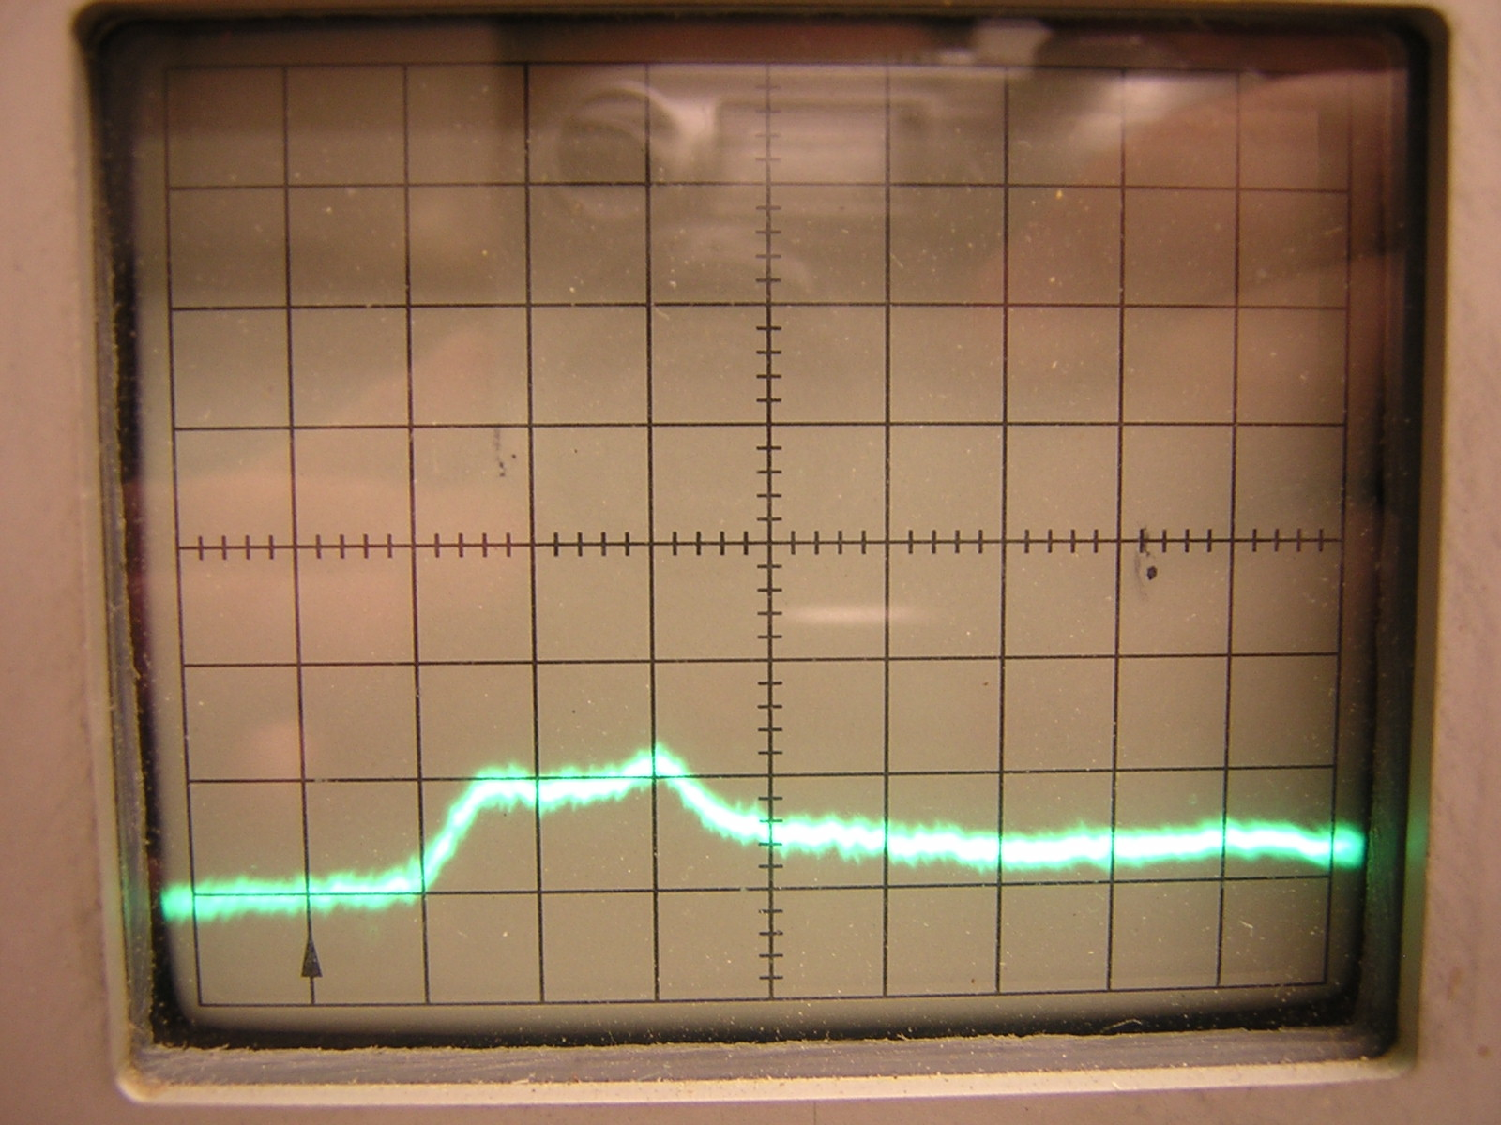
20 mρ / div & 0.1 ft/div

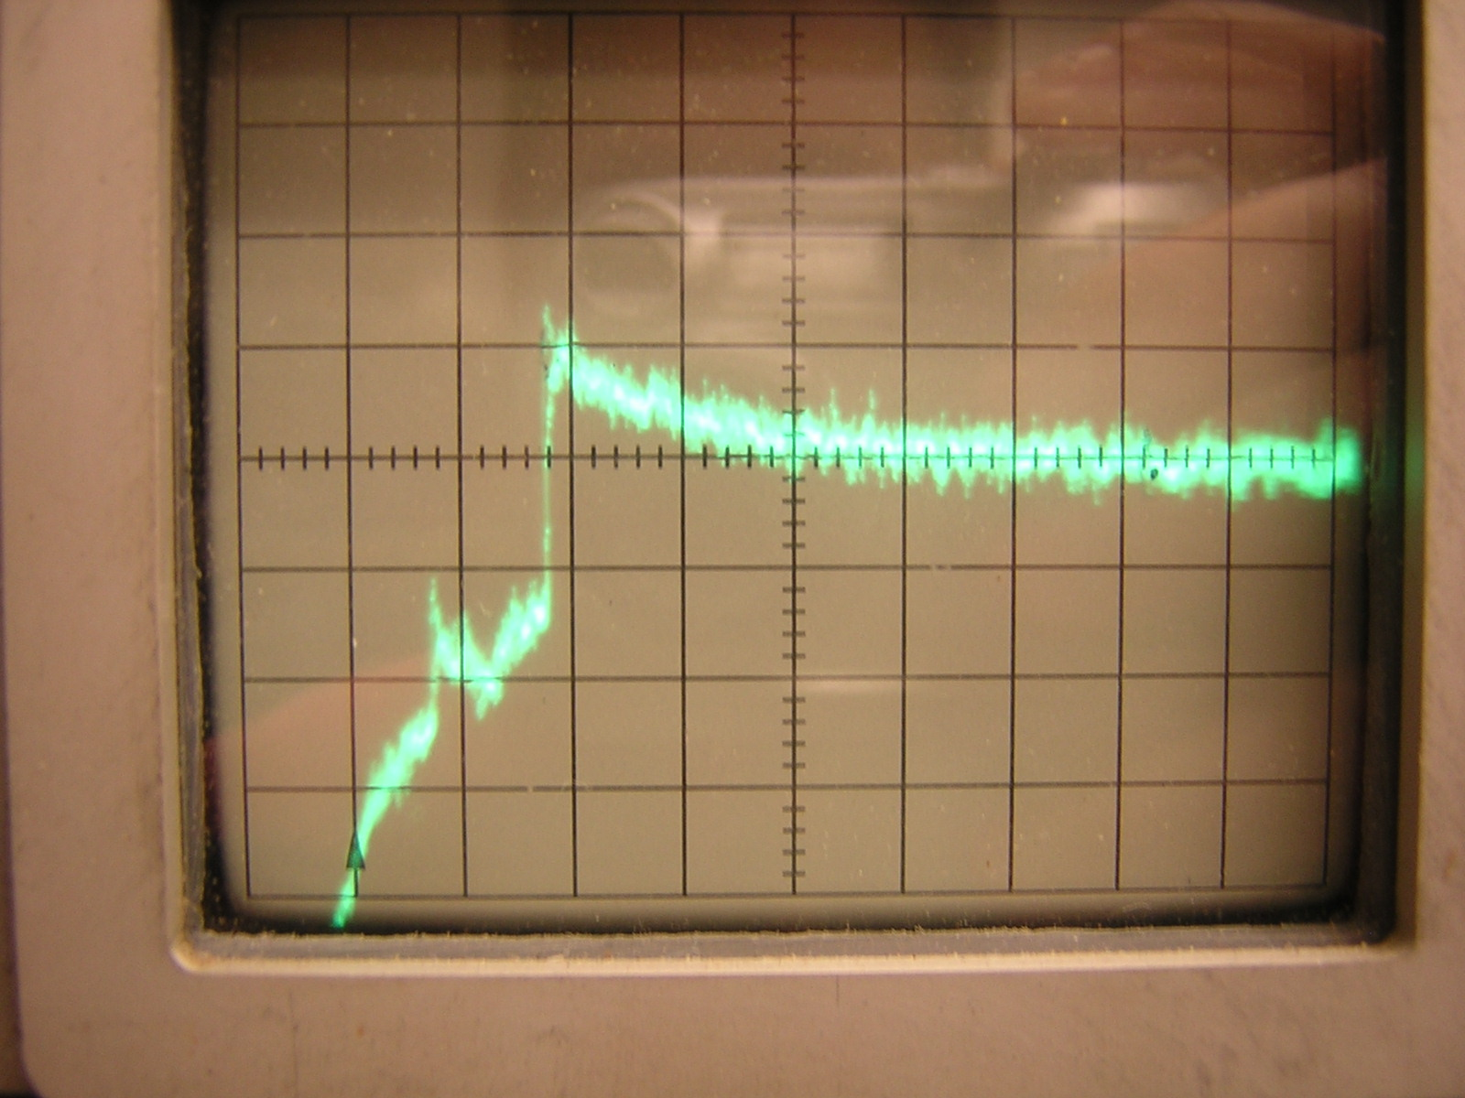
10 mρ / div & 10 ft/div

All reflection coefficients from now on are with respect to the input cable.

Kyocera SMA Feedthrough

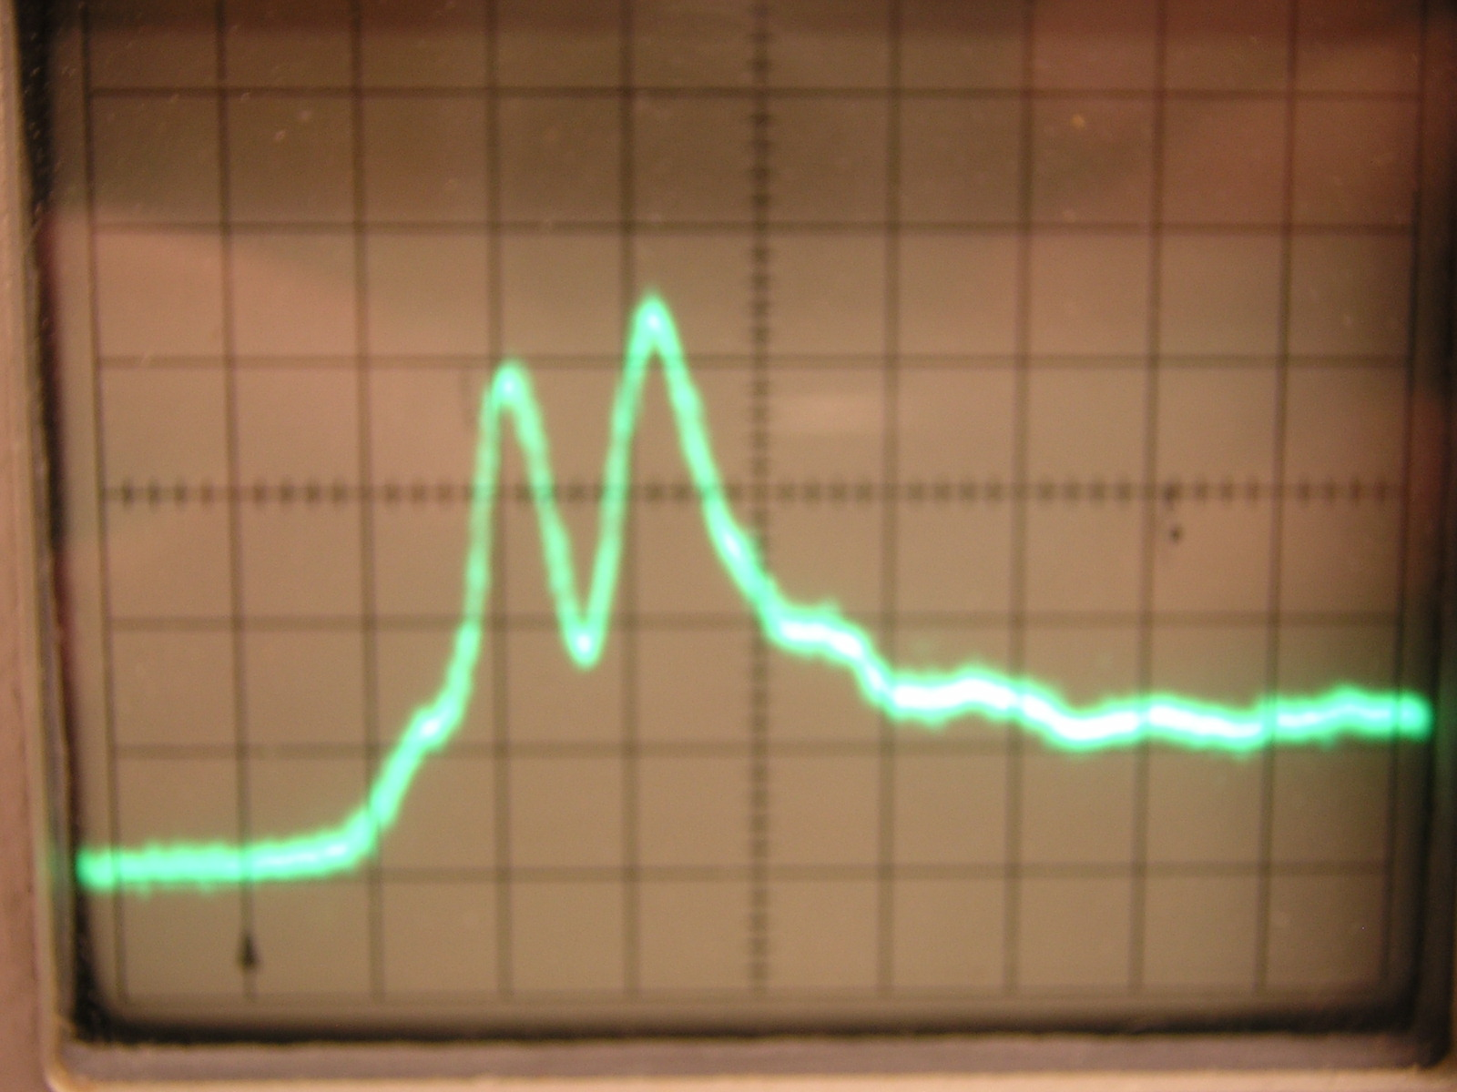
20 mρ / div & 0.1 ft/div
Input feedthru ρ = +0.08 (net ρ wrt 50 Ω = +0.057)
Output feedthru ρ = +0.09 (net ρ wrt 50 Ω = +0.067)

Reversing the test jig:

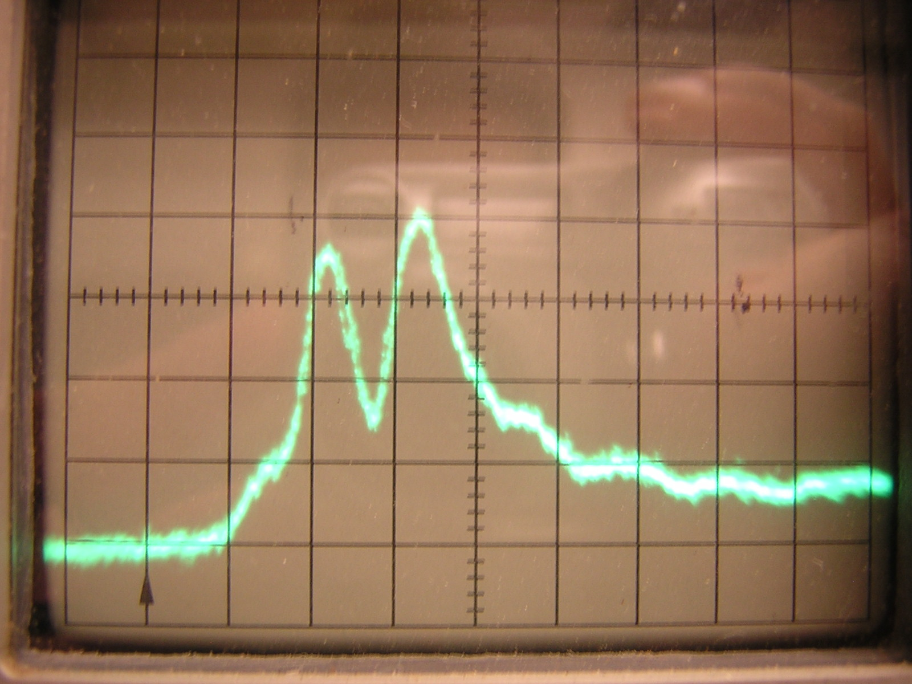
20 mρ / div & 0.1 ft/div
Input feedthru ρ = +0.07 (net ρ wrt 50 Ω = +0.047)
Output feedthru ρ = +0.08 (net ρ wrt 50 Ω = +0.057)

MPF SMA Feedthrough

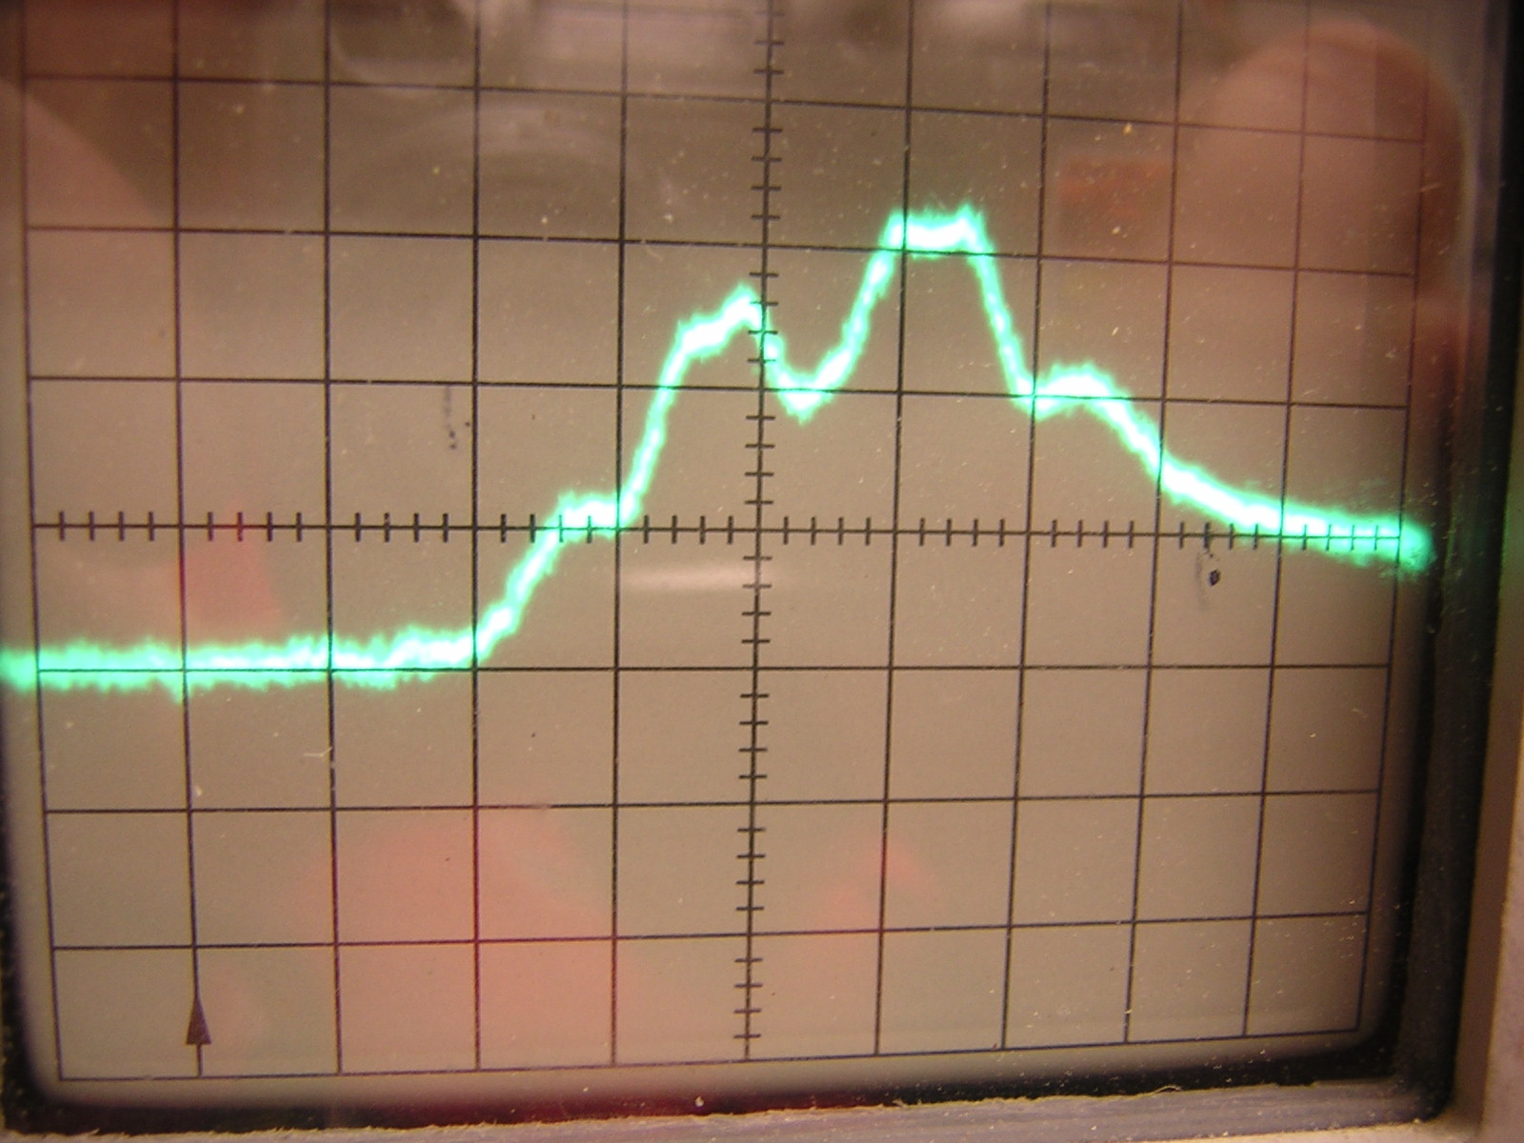
20 mρ / div & 0.1 ft/div
Input feedthru ρ = +0.050 (net ρ wrt 50 Ω = +0.027)

Reversing the test jig:

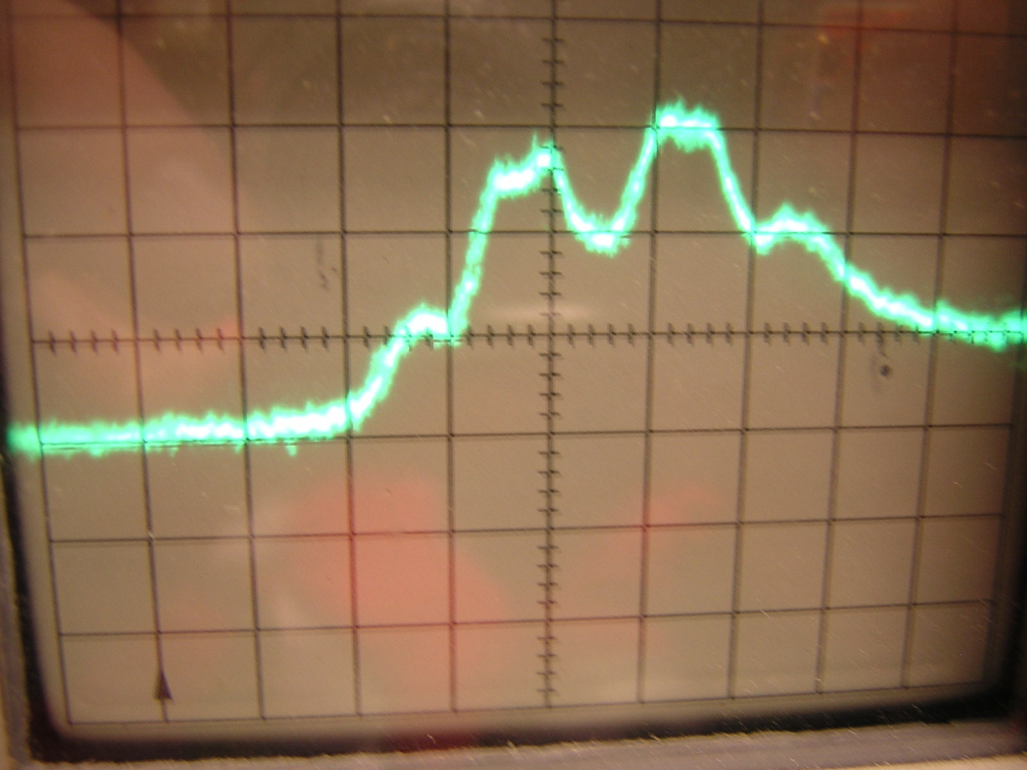
20 mρ / div & 0.1 ft/div
Input feedthru ρ = +0.055 (net ρ wrt 50 Ω = +0.032)

Ceramaseal SMA Feedthrough

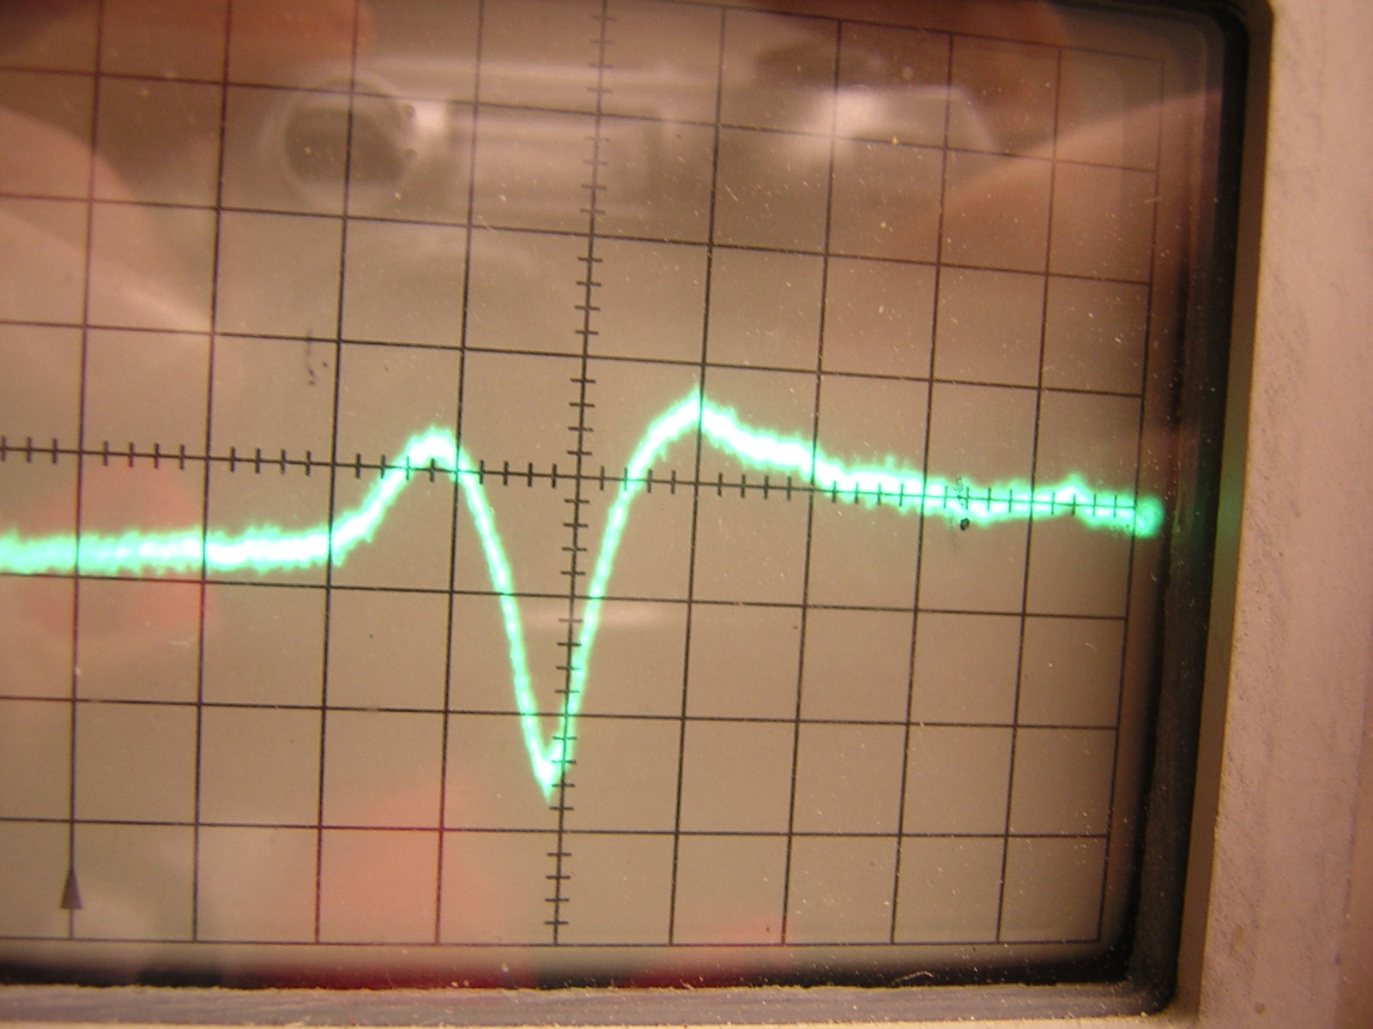
20 mρ / div & 0.1 ft/div
Input feedthru ρ = +0.021 (net ρ wrt 50 Ω = -0.002)

Our test jig is not very stable – we needed to hold the parts centered as well as possible.

Reversing the test jig

Test 2nd feedthru
Input feedthru ρ = +0.022 (net ρ wrt 50 Ω = -0.001)

Test 3rd feedthru
Input feedthru ρ = +0.022 (net ρ wrt 50 Ω = -0.001)

Stripline
Test with stripline by holding the feedthru on the extension post.

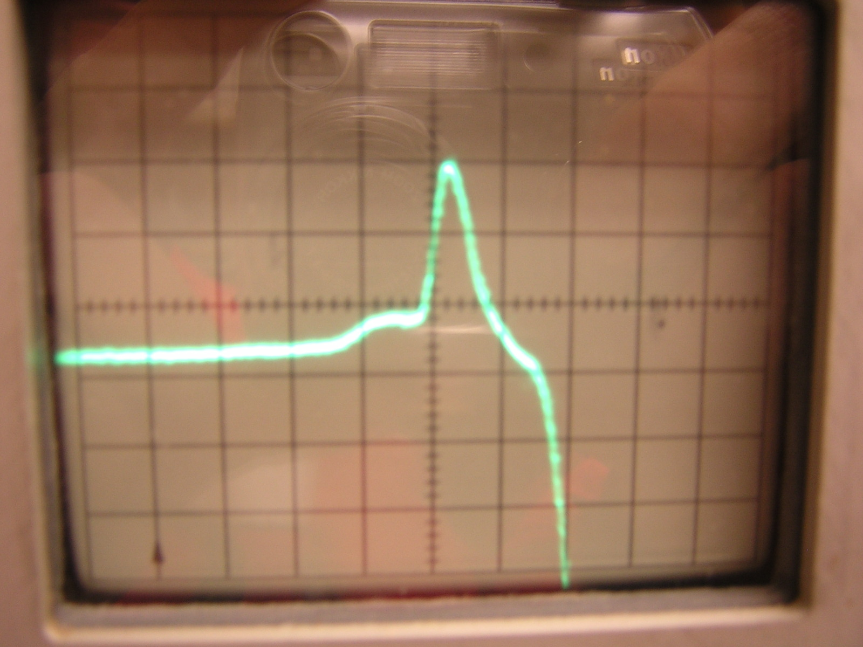
50 mρ / div & 0.1 ft/div
Input ρ = +0.075
Stripline ρ = -0.01 → Z = 47.0 Ω

The strip width needs to be narrowed by about 6.0% or the gap needs to be increased by about 6.0%.

Nov. 14, 2005
M. Palmer, M. Billing

Stripline after Re-machining the Extension Post
Test with stripline by holding the Ceramaseal SMA feedthru on the extension post. The extension post has been re-machined to have a lower inductance connection. The plot below includes a 90° SMA angle fitting before the feedthru. Notice that the fitting’s match is very good!

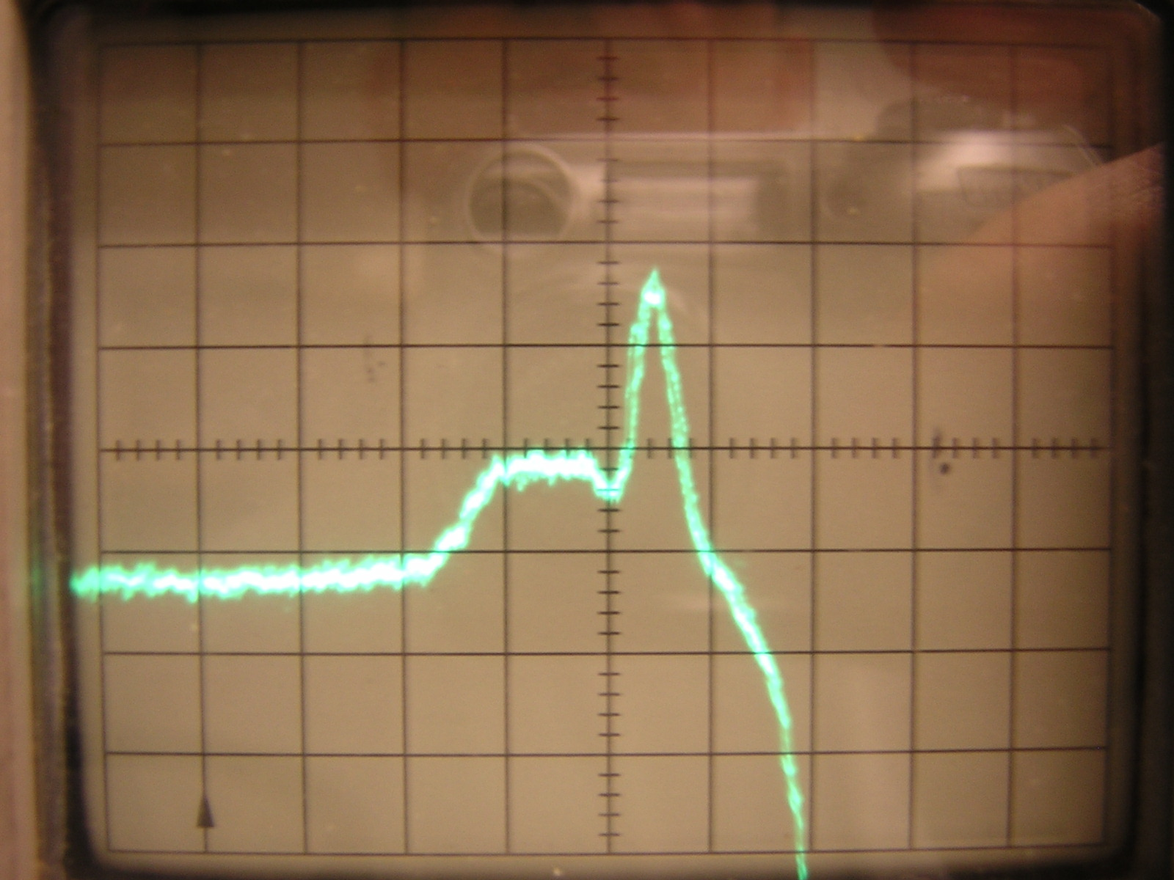
20 mρ / div & 0.1 ft/div
Input ρ = +0.054 (net ρ wrt 50 Ω = 0.034)
Stripline ρ = ~0.0 → Z = ~ 48 Ω (poor measurement)

Added Somewhat Better Matching for the End of the Stripline
Next added a piece of copper tape on the inside of the outer tube where the feedthru center conductor passes the hole in the tube’s wall. As seen below this piece of tape causes a slight capacitive dip visible at 5.7 divisions horizontally. Added several pieces of copper tape to build a ramp on the stripline at the end, which connects to the Ceramaseal center conductor. This ramp begins 12 mm before the end of the strip and tapers to increase the outside diameter of the strip by about 1 mm. The ramp is across the entire width of the strip. This ramp has increased the capacitance at the connection point between strip and the feedthru’s center conductor, thereby reducing the (positive) inductive peak at 6.1 divisions.

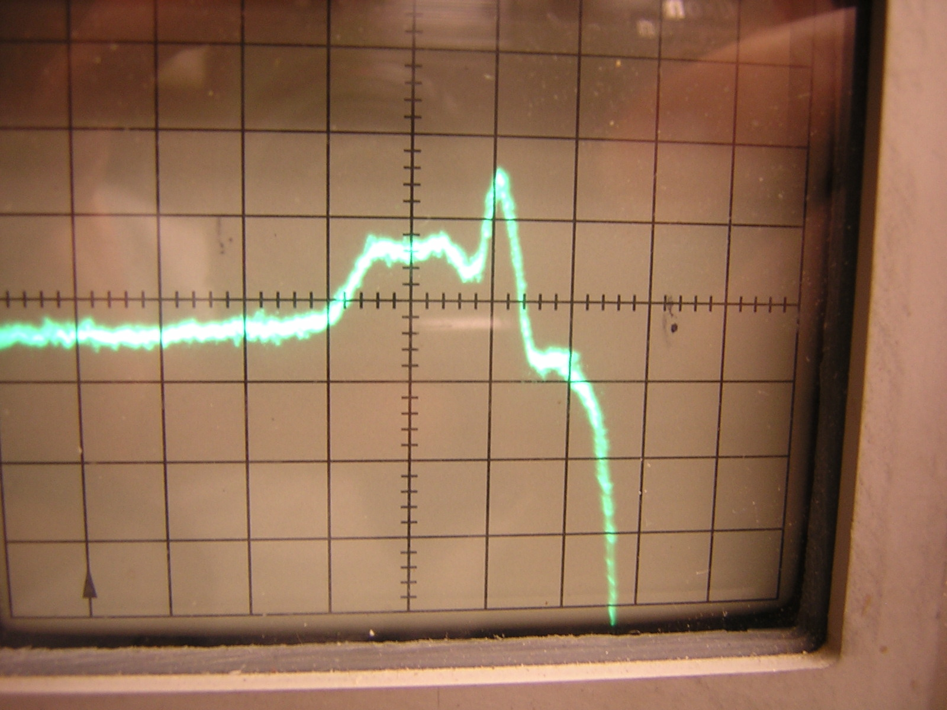
20 mρ / div & 0.1 ft/div
Input ρ = +0.036/+0.012 (net ρ wrt 50 Ω = +0.016/-0.008)
Stripline ρ = -0.007 → Z = 47.3 Ω (much better measurement)
→ Will need to be made narrower by approximately (50-47.3)/50 = 5.4%

Dec. 2, 2005
M. Palmer, M. Billing

Stripline after Re-machining the Taper at the Feedthru
Test with stripline by holding the Ceramaseal SMA feedthru on the extension post. The stripline has been re-machined at the transition to the feedthru pin to taper to a narrower width. In this transition a taper toward the outside wall has been added to keep the impedance constant. The net effect should be to also to lower the inductance of the connection. The plot below includes a 90° SMA angle fitting before the feedthru. The match is clearly improved!
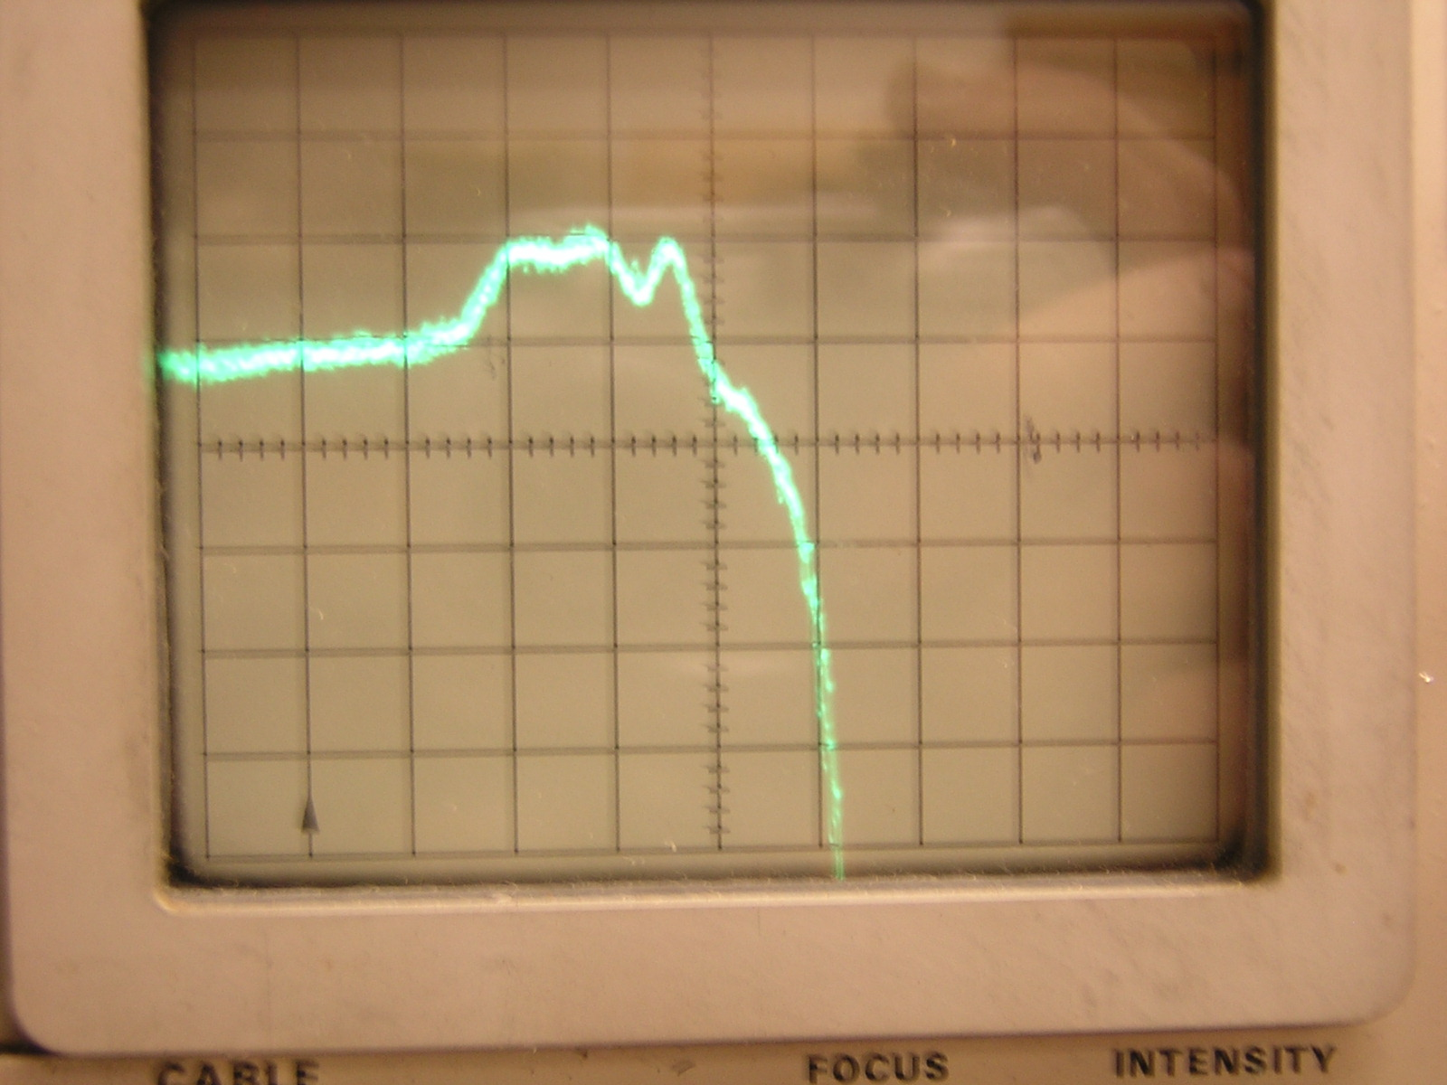
20 mρ / div & 0.1 ft/div
Input taper ρ = +0.010 (net ρ wrt 50 Ω = -0.010)
Stripline ρ = -0.016 (net ρ wrt 50 Ω = -0.036)
Stripline ρ = -0.036 → Z = 46.0 Ω (much better measurement)
→ Will need to be made narrower by approximately (50-46.0)/50 = 7.0%

