ILC Damping Rings Component/Subsystem Specification

Part I – Classification Information
Component Description: | Quadrupole magnet power cable
Component Location (beamline): | EDR, PDR I, PDR II | Lattice Version: |  | OCS6, 2006-06-30
Document Number: | EDR-MAG-cbl-002 |  | Date: | 2006-08-03
Prepared by: | Andy Wolski (Cockcroft) |  | email: | a.wolski@dl.ac.uk
Technical/Global System: | Magnets
Technical/Global System Contact: | John Tompkins (FNAL) |  | email: | jct@fnal.gov
DR Area System Contact: | Mike Zisman (LBNL) |  | email: | mszisman@lbl.gov

Part II – Main Parameters
Parameter | Value | Reference
Quantity per beamline | 614 km | [1]
Conductor | Copper
Electrical conductivity | 60×10⁻⁶ Ω⁻¹m⁻¹
Density | 8920 kg/m³
Conductor cost | Public version: no costs shown | [2]
Cable resistance | 0.3315 Ω/km
Cable diameter | 8.0 mm
Cable mass | 0.4 kg/m
Maximum current | 175 A | [3]
Voltage drop at maximum current | 58.0 V/km
Unit cost per metre | Public version: no costs shown

ILC Damping Rings Component Specification

Document Number: | EDR-MAG-cbl-002 | Date: | 2006-08-03

Part III – Other Parameters, Information, and Drawings
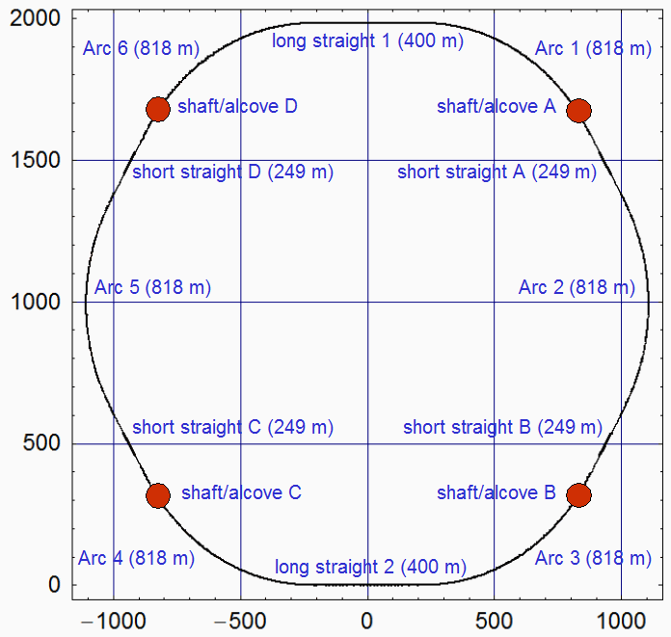

Figure 1: Schematic Layout

Part IV – References
[1] Each quadrupole separately powered. Cable lengths based on distance to nearest alcove.

[2] London Metal Exchange: http://www.lme.co.uk

[3] EDR-MAG-quad-005

