ILC Damping Rings Component Specification Sheet

Part I – Classification Information
Component Description: | Generic Damping Ring Sextupole
Component Location (beamline): | EDR/PDR I/PDR II | Lattice Version: |  | OCS6, 2006-06-20
Document Number: | EDR-MAG-sxt-002 |  | Date: | 2006-07-12
Prepared by: | Jin-Young Jung |  | email: | JYJung@lbl.gov
Technical/Global System: | Magnets
Technical/Global System Contact: | John Tompkins |  | email: | jct@fnal.gov
DR Area System Contact: | Mike Zisman |  | email: | mszisman@lbl.gov

Part II – Main Parameters
Parameter | Value | Reference
Quantity per beamline | 480 | [1]
Length | 250 m
Pole-tip radius | 30 mm
Maximum pole-tip field in lattice | 0.00720 T
Minimum pole-tip field in lattice | 0.00467 T
Maximum design pole-tip field | 0.00756 T | [2]
Total current per pole | 64.4 Ampere-turns
Current density | 95.3 Amperes/cm²
Conductor | #10 AWG square conductor, heavy insulation
Number of turns | 1×9
Current | 7.2 Amperes
Voltage | 0.53 Volts
Power per magnet | 3.8 W
Cooling water power rise | No water cooling
Cooling water flow rate | No water cooling
Field quality (dg/g) | 0.54% at r = 2.5 cm
Magnet efficiency | 98.3%
Core volume | 0.004 m³
Core mass | 73.12 lb
Coil mass | 4.05 lb
Core cost | Public version: no cost information shown | [3]
Coil cost | Public version: no cost information shown | [3]
Assembly and test | Public version: no cost information shown | [3]
Unit Cost | Public version: no cost information shown

ILC Damping Rings Component Specification Sheet

Document Number: | EDR-MAG-sxt-002 | Date: | 2006-07-12

Part III – Other Parameters, Information, and Drawings
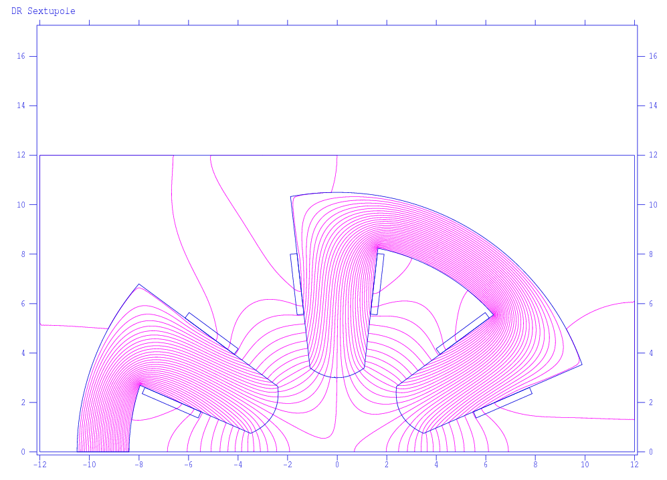

Field in poles ~ 0.0107 T
Field in yoke ~ 0.0305 T

ILC Damping Rings Component Specification Sheet

Document Number: | EDR-MAG-sxt-002 | Date: | 2006-07-12

Part IV – References
[1] Includes only sextupoles with non-zero values in OCS6.

[2] Actual maximum design pole-tip field is 0.00794 T; the quoted value is the effective maximum design pole-tip field, allowing 5% reduction from end effects.

[3] Scaled from ALS costs, plus inflation increase of 4% per year from 1989 to 2006.

