ILC Damping Rings Component/Subsystem Specification

Part I – Classification Information
Component Description: | Electron DR Wiggler Straight Quadrupole Vacuum Chamber
Component Location (beamline): | EDR | Lattice Version: |  | OCS6, 2006-06-30
Document Number: | EDR-VAC-chmb-004 |  | Date: | 2006-08-22
Prepared by: | Steve Marks (LBNL)  Dave Plate (LBNL) |  | email: | s_marks@lbl.gov  dwplate@lbl.gov
Technical/Global System: | Vacuum
Technical/Global System Contact: | John Noonan |  | email: | noonan@aps.gov
DR Area System Contact: | Andy Wolski |  | email: | a.Wolski@dl.ac.uk

Part II – Main Parameters
Parameter | Value | Reference
Quantity per beamline | 80
Operating pressure | 1×10⁻⁹ torr | [1]
Length | 1.0 meter
Unit Cost | Public version: no costs information shown

Part III – Other Parameters, Information, and Drawings
Keep power density below 15 W/mm²

Keep physical cross sectional size to fit within the quadrupole design (30 mm magnetic aperture).

Length= 1.0 m

Chamber designed without absorbers. All power absorbed within wiggler chambers.

Surface coating for reduction of secondary electrons. (Will be required for the PDR’s, assume coating of all chambers)

Currently does not include clearing electrodes.

Estimate includes a 40 l/s ion pump with power supply, a bellows assembly with RF interface, and a BPM assembly.

ILC Damping Rings Component Specification

Document Number: | EDR-VAC-chmb-004 | Date: | 2006-08-22

Part III – Other Parameters, Information, and Drawings (continued)
Item | Unit | Units/chamber | $/Unit | $/m
Aluminum | Kg | 23.1
¹Machining (Coarse) | hr | 1
¹Machining (Fine) | hr | 1.5
NEG Coating | m | 1
Welding | hr | 2
Cleaning | hr | 2
Fixtures | m | 1
Ion Pump 40 l/s | m | 1
IP Power Supply | m | 1
BPM/Bellows Assembly
Bellows/RF Assembly | m | 1
BPM Buttons | ea | 4
Machining/Welding | hr | 2
Total

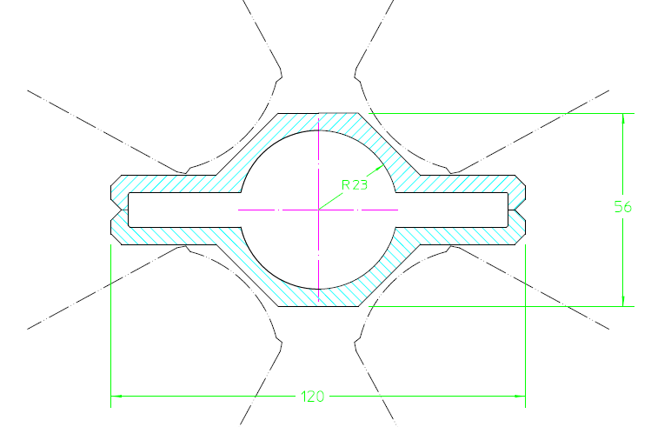

Cross-section of wiggler section quadrupole vacuum chamber. The chamber is NEG-coated.

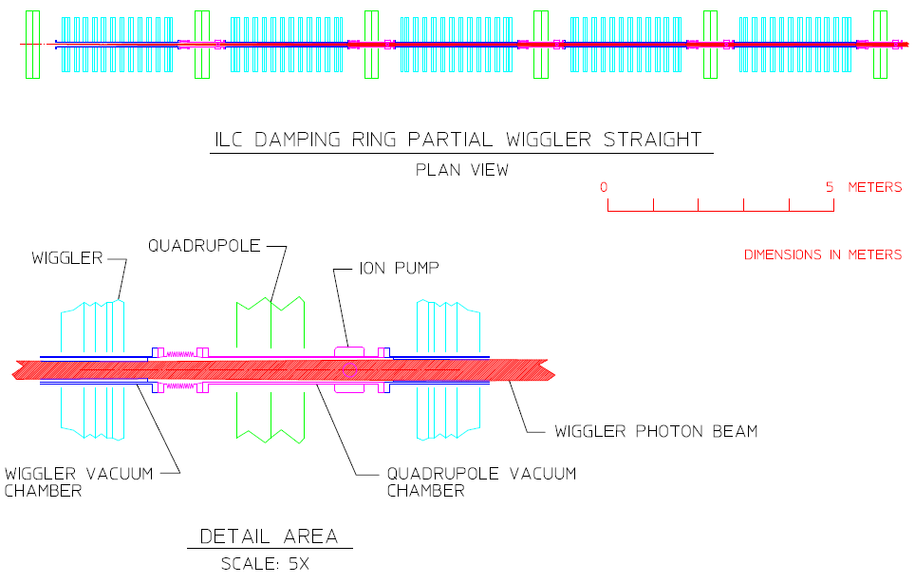

ILC Damping Rings Component Specification

Document Number: | EDR-VAC-chmb-004 | Date: | 2006-08-22

Part IV – References
[1] A. Wolski, J. Gao, S. Guiducci, “Configuration Studies and Recommendations for the ILC Damping Rings”, LBNL-59449, February 2006.

