ILC Damping Rings Component/Subsystem Specification

Part I – Classification Information
Component Description: | Electron damping ring injection line tunnel
Component Location (beamline): | EDRI | Lattice Version: |  | OCS6, 2006-06-30
Document Number: | EDRI-CONV-tnl-001 |  | Date: | 2006-08-23
Prepared by: | Andy Wolski |  | email: | a.wolski@dl.ac.uk
Technical/Global System: | CF&S
Technical/Global System Contact: | Tom Lackowski |  | email: | tomski@fnal.gov
DR Area System Contact: | Andy Wolski |  | email: | a.wolski@dl.ac.uk

Part II – Main Parameters
Parameter | Value | Reference
Tunnel length | 27.127 m | [1]
Tunnel diameter | 4 m | [2]
Tunnel cost/meter | Public version: no costs information shown. | [3]

Part III – Other Parameters, Information, and Drawings
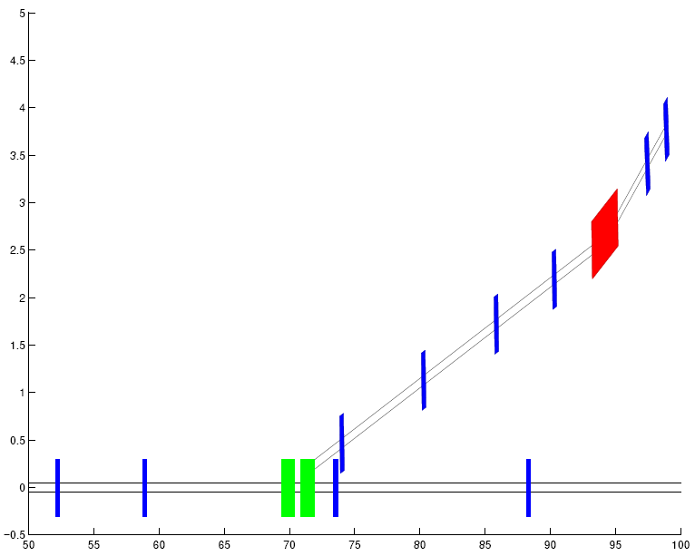

ILC Damping Rings Component Specification

Document Number: | EDRI-CONV-tnl-001 | Date: | 2006-08-23

Part IV – References
[1] Lattice design by Ina Reichel, LBNL.

[2] Assumed same as damping ring tunnel. Component Specification Sheet EDR-CONV-tnl-001.

[3] CF&S Spreadsheet DR_cut_CFS_Cost_Draft_6_30_06.

