ILC Damping Rings Component/Subsystem Specification

Part I – Classification Information
Component Description: | Positron Damping Ring Tunnel
Component Location (beamline): | PDR1/PDR2 | Lattice Version: |  | OCS6, 2006-06-20
Document Number: | PDR1-CONV-tnl-001 |  | Date: | 2006-08-22
Prepared by: | Andy Wolski |  | email: | a.wolski@dl.ac.uk
Technical/Global System: | CF&S
Technical/Global System Contact: | Tom Lackowski |  | email: | tomski@fnal.gov
DR Area System Contact: | Andy Wolski |  | email: | a.wolski@dl.ac.uk

Part II – Main Parameters
Parameter | Value | Reference
Number of beamlines in tunnel | 2 | BCD
Humidity control requirement | Yes
Maximum tunnel temperature | 110°F (43°C) | [1]
Tunnel access frequency
Tunnel total length (ring circumference) | 6695 m | [2]
Tunnel diameter | 4 m
Tunnel cost/meter | Public version: no costs information shown | [3]
Part IIA – Non-wiggler Magnet and Magnet Power Supplies Parameters
Parameter | Value | Reference
Magnets technology | Normal conducting electromagnet | BCD
Dipole max width | 346 mm | [4]
Dipole max length | 6.140 m | [4]
Dipole max weight | 1550 kg | [4]
Quadrupole max width | [To be provided by Magnet Systems Technical Group]
Quadrupole max length | [To be provided by Magnet Systems Technical Group]
Quadrupole max weight | [To be provided by Magnet Systems Technical Group]
Magnet service access | From one side only
Power supply locations | Every x meters
Power supplies dimensions | [To be provided by Magnet Systems Technical Group]
Power supplies weight | [To be provided by Magnet Systems Technical Group]
Power supplies quantities | [To be provided by Magnet Systems Technical Group]
Total magnets power requirement | See Power Budget (section III)
Magnets power to cooling water | See Power Budget (section III)
Magnets power to air | See Power Budget (section III)
Part IIB – Wiggler Parameters
Parameter | Value | Reference
Wiggler technology | Superferric | BCD
Wiggler length | 4 locations with ~ 50 m per location per ring (2 rings)
Wiggler width
Wiggler weight
Total wiggler radiation power | See Power Budget (section III)
Radiation power to cooling water | See Power Budget (section III)
Radiation power to air | See Power Budget (section III)
Total cryogenic power

ILC Damping Rings Component Specification

Document Number: | PDR1-CONV-tnl-001 | Date: | 2006-08-22
Part IIC – RF Parameters
Parameter | Value | Reference
RF system | Superconducting | BCD
RF cavity cryomodule quantities | 16 per ring (in four locations)
RF cavity cryomodule length | ~ 3.5 m | [5]
RF cavity cryomodule width | ~ 1.5 m | [5]
RF cavity cryomodule weight | [To be provided by RF Power Technical Group]
RF cavity cryomodule service access | From both sides
Klystrons dimensions | [To be provided by RF Power Technical Group]
Klystrons weight | [To be provided by RF Power Technical Group]
Klystrons quantities | 4 per ring (in four locations)
Total RF power requirement | See Power Budget (section III)
RF power to cooling water | See Power Budget (section III)
RF power to air | See Power Budget (section III)
RF power to beam | See Power Budget (section III)

Part III – Other Parameters, Information, and Drawings
Power Budget:

 | Input kW |  | Duty  factor | Output kW |  |  | Location
 | Wall-plug | From beam |  | To beam | To water | To air
RF Power (base value) | 6300 | 0 | 1.00 | 3500 | 2300 | 500 | Alcoves
RF Power (peak overhead) | 700 | 0 | 0.10 | 0 | 70 | 0 | Tunnel
Water-cooled magnets¹ | 2198 | 0 | 1.00 | 0 | 2198 | 0 | Tunnel
Air-cooled magnets² | 218 | 0 | 1.00 | 0 | 0 | 218 | Tunnel
Cables | 2754 | 0 | 1.00 | 0 | 0 | 2754 | Tunnel
Magnet power supply losses | 728 | 0 | 1.00 | 0 | 0 | 728 | Alcoves
Injection/extraction kickers (avg) | 886 | 0 | 1.00 | 0 | 886 | 0 | Tunnel
Radiation | 0 | 3500 | 1.00 | 0 | 2800 | 700 | Tunnel
Total | 13784 |  |  |  | 8254 | 4900

¹ Dipoles, quadrupoles and septa.
² Sextupoles, orbit correctors and skew quadrupoles.

ILC Damping Rings Component Specification

Document Number: | PDR1-CONV-tnl-001 | Date: | 2006-08-22

Tunnel layouts and drawings are given in:

EDR-CONV-tnl-001a.pdf
EDR-CONV-tnl-001b.pdf
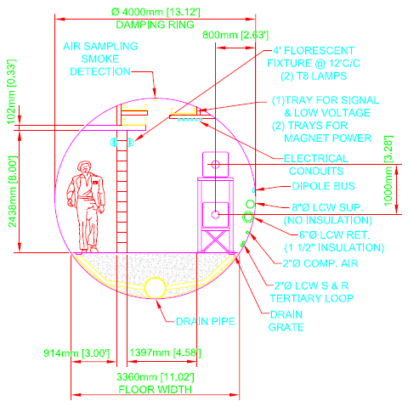

Part IV – References
[1] Private communication (email), Emil Huedem, 2006-06-13.

[2] OCS6, Lattice design 2006-06-20
https://wiki.lepp.cornell.edu/ilc/bin/view/Public/DampingRings/WebHome

[3] CF&S Spreadsheet DR_cut_CFS_Cost_Draft_6_30_06.

[4] 6 m dipole. Component Specification Sheet: EDR-MAG-dip-002.

[5] Based on CESR-c or KEK-B cryomodules

