ILC Damping Rings Costing Handbook

20 April, 2006

1. Roles and Contacts List

DR Subsystem Expert
The subsystems experts should work with one of the DR Area System Leaders, to draw up the technical specifications for components within their subsystem. The specifications should be based on:
- the damping rings lattice design;
- the subsystem performance specifications;
- the information required by the corresponding Technical or Global Group, for a complete description and costing.
The technical specifications should be recorded on a Components Specifications Sheet, and filed on the Damping Rings RDR Wiki site, accessible from:
http://www.lns.cornell.edu/ilc/
(follow links to Damping Rings Area System, and WG3B RDR Page).

DR Area Systems Leaders
The DR Area Systems Leaders should initially work with the DR Subsystem Experts and the Technical and Global Group contacts, to agree formats for the Component Specifications Sheets, and to define the information that will be recorded on them. As the work proceeds, the Area Systems Leaders should:
- review the component specifications for accuracy, completeness, ability to meet the performance specifications, and consistency with other component specifications and descriptions;
- take joint responsibility with the Subsystem Experts for seeing that the Component Specification Sheets are completed and filed on the DR RDR Wiki site;
- ensure that information is exchanged with the Technical and Global Groups;
- collect the cost numbers (from the Technical and Global Groups) for components described in the Component Specifications Sheets.

Technical and Global Group Contacts
The Technical and Global Group Contacts should initially work with the DR Area Systems Leaders and the Subsystem Experts, to agree formats for the Component Specifications Sheets, and to define the information that will be recorded on them. As the work proceeds, the Technical and Global Group Contacts should:
- review the component specifications for accuracy, completeness, ability to meet the performance specifications, and consistency with other component specifications and descriptions;
- provide cost estimates for the components.
The cost estimates should be passed to the appropriate DR Area Systems Leader.

Damping Rings Technical Subsystems Experts and Area Systems Leaders:

Subsystem | Subsystem Expert | email | DR-ASL
Injection and extraction systems | George Gollin | g-gollin@mail.physics.uiuc.edu | JG
Magnets (including wiggler) | Mark Palmer | map36@cornell.edu | JG
Support and alignment hardware | Aimin Xiao | xiaoam@aps.anl.gov | JG
Diagnostics and instrumentation | Marc Ross? | mcrec@slac.stanford.edu | SG
Control system | Marc Ross? | mcrec@slac.stanford.edu | SG
Fast feedback system | Alessandro Drago | Alessandro.Drago@lnf.infn.it | SG
RF system | Roberto Boni | Roberto.Boni@lnf.infn.it | SG
Conventional facilities |  |  | AW
Vacuum system | Oleg Malyshev | o.b.malyshev@dl.ac.uk | AW
Dumps and collimators |  |  | MZ
Installation, operations, availability |  |  | MZ

ILC Technical and Global Systems Contacts:

Technical or Global Group, or Board | Contact | email | DR-ASL
Magnets | John Tompkins | jct@fnal.gov | JG
Cryogenics - Wiggler | Laurent Tavian | laurent.tavian@cern.ch | JG
Cryogenics - RF | Laurent Tavian | laurent.tavian@cern.ch | SG
RF Power | Shigeki Fukuda | shigeki.fukuda@kek.jp | SG
Instrumentation |  |  | SG
Control system | John Carwardine | carwar@aps.anl.gov | SG
Vacuum | John Noonan | noonan@aps.anl.gov | AW
Conventional facilities and siting | Tom Lackowski | tomski@fnal.gov | AW
Design Cost Board (DCB) | Jean-Pierre Delahaye | jean-pierre.delahaye@cern.ch | AW
Installation |  |  | MZ
Commissioning, operations and reliability |  |  | MZ
Dumps and collimators |  |  | MZ
Accelerator physics |  |  | All

Damping Rings Area Systems Leaders (DR-ASLs):

JG: Jie Gao (gaoj@ihep.ac.cn)
SG: Susanna Guiducci (susanna.guiducci@lnf.infn.it)
AW: Andy Wolski (a.wolski@dl.ac.uk)
MZ: Mike Zisman (mszisman@lbl.gov)

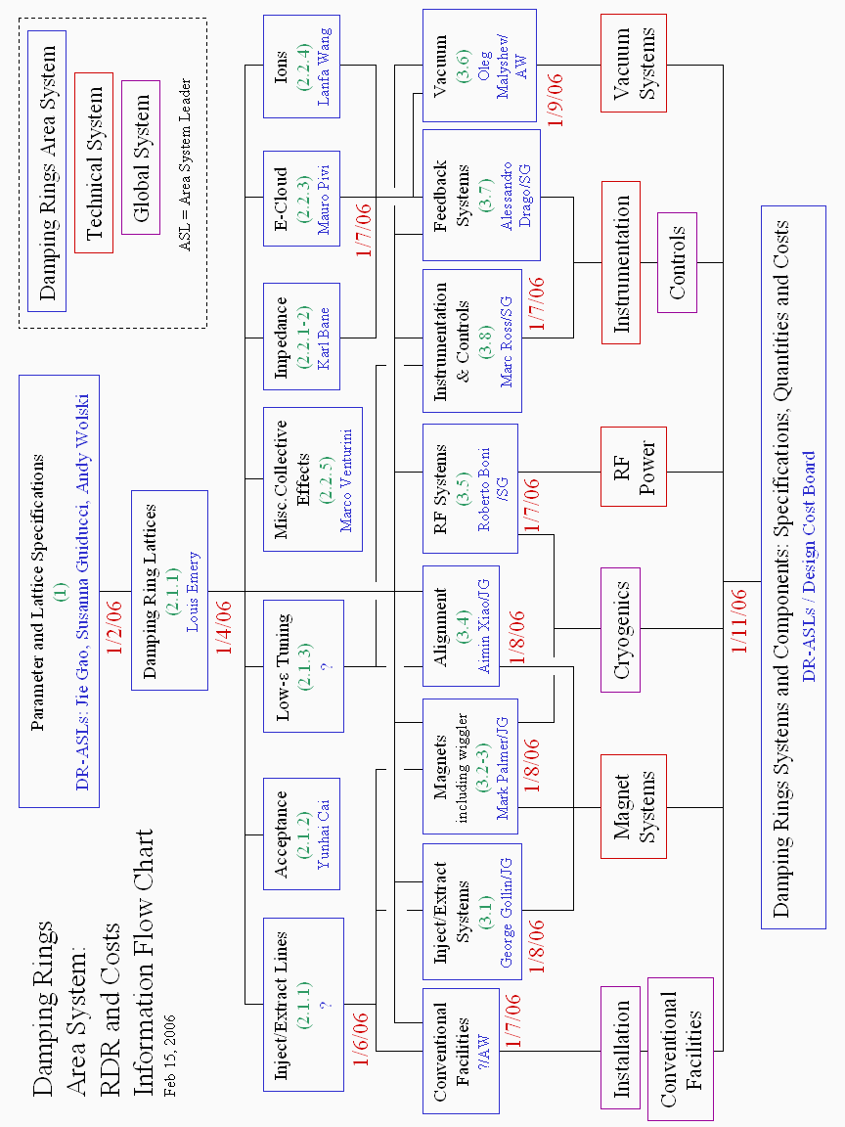
This page is intentionally left blank
2. Component Specification Sheets

Component specifications should be listed on an “ILC Damping Rings Component Specifications” sheet. This sheet will include the main component parameters, the location (i.e. which beamline the component appears in), the quantity, the unit cost, and other useful and relevant information. To make it easier to keep track of the specifications sheets, each sheet should have a unique Document Number, that identifies the beamline, the technical subsystem to which the component belongs, and the type of component.

The Component Specifications Sheets should be a record of information exchanged between the Damping Rings Area System and the Technical Systems and Global Systems groups. At the outset, the Damping Rings Experts and Area Systems Leaders should confirm with the appropriate contacts in the Technical Systems and Global Systems groups:
- the format of the Components Specifications Sheets
- the information needed for different types of component.
Examples of suggested formats are given at the end of this handbook. It is not necessary to adhere rigidly to the example formats: it is important that the format is appropriate to the type of component it describes.

Once the format and the needed information are agreed, the sheets should be completed with as much of the required information as possible. The Damping Rings Experts and Area System Leaders are responsible for seeing that the sheets are completed, but do not necessarily have to complete every sheet themselves.

The appropriate Damping Rings Area System Leader should send completed sheets to the Technical System or Global System contact, for review and costing. Costed sheets should be returned to the Area System Leader, who should then send a copy to Andy Wolski (responsible for keeping a central repository).

It may be acceptable to take a “top-down” approach to the costing of a particular subsystem, by scaling from existing machines. For example, the entire vacuum system might be estimated by scaling from the APS vacuum system. If it is decided to take such an approach, the specifications and scaling arguments (in other words, the basis for the cost) should still be recorded on a Component Specifications Sheet.
3. Component Specification Sheets: Document Numbering Scheme

Document Numbers should be of the form: BEAMLINE-TECHSUB-type-index

where:

BEAMLINE refers to the beamline in which the component is located;
TECHSUB refers to the technical subsystem the component is part of;
type refers to the type of component;
index is an (arbitrary) index number.

Possible BEAMLINE values are:

EDRI | electron damping ring injection line
EDR | electron damping ring
EDRX | electron damping ring extraction line
PDR1I | positron damping ring 1 injection line
PDR1 | positron damping ring 1
PDR1X | positron damping ring 1 extraction line
PDR2I | positron damping ring 2 injection line
PDR2 | positron damping ring 2
PDR2X | positron damping ring 2 extraction line

Possible TECHSUB (technical subsystem) values are:

CONV | conventional facilities
CTRL | control system
DIAG | diagnostics and instrumentation
FFB | fast feedback system
INX | injection and extraction systems
MAG | magnets (including wiggler and power supplies)
RF | RF system
SUPT | support and alignment hardware
VAC | vacuum system

Note: injection and extraction system components are counted as part of the appropriate injection or extraction line, and not as part of the damping ring.
Possible type values depend on the technical subsystem. The following list can be extended and updated as necessary.

CONV (conventional facilities)
acs | access shaft
cav | alcove or cave (for klystrons, control racks etc.)
tnl | tunnel
wtr | water supply

CTRL (control systems)
cons | control console
mnfm | mainframe
vme | area controller
daq | data acquisition unit
cnt | controller

DIAG (diagnostics and instrumentation)
int | beam intensity diagnostic
bpm | beam position diagnostic
siz | beam size diagnostic
misc | other beam diagnostic

FFB (fast feedback system)
pic | pickup
amp | amplifier
kic | kicker

INX (injection and extraction systems)
strp | kicker stripline
feed | feedthrough
plsr | pulser
pspy | pulser power supply
spt | septum
sspy | septum power supply

MAG (magnets)
dip | dipole
quad | quadrupole
sxt | sextupole
mult | higher-order multipole (octupole, decapole…)
skw | skew quadrupole
str | steering magnet (orbit corrector)
mspy | magnet power supply
wglr | wiggler
wcry | wiggler cryogenics
wspy | wiggler power supply

RF (RF system)
kly | klystron
kspy | klystron power supply
wvgd | waveguide
cav | RF cavity
rfcr | RF cryogenics

SUPT (support and alignment hardware)
grd | girder
sprt | magnet support

VAC (vacuum system)
chmb | vacuum chamber
pmp | vacuum pump
vspy | vacuum pump power supply
gge | vacuum gauge

Examples of document numbers:

PDR2I-MAG-quad-003: quadrupole magnet in positron damping ring 2 injection line.
EDRX-INX-sspy-001: power supply for septum in electron damping ring extraction line.
PDR1-MAG-wcry-001: cryogenics for wiggler in positron damping ring 1.
ILC Damping Rings Component Specification Sheet

Part I – Classification Information
Component Description:
Component Location (beamline): |  | Lattice version:
Document Number: |  | Date: | 2006-mm-dd
Prepared by: |  | email:
Technical/Global System:
Technical/Global System Contact: |  | email:
DR Area System Contact: |  | email:

Part II – Main Parameters
Parameter | Value | Reference
Quantity per beamline
Unit Cost

Part III – Other Parameters, Information, and Drawings

ILC Damping Rings Component Specification Sheet

Document Number: |  | Date: | 2006-mm-dd

Part IV – References

ILC Damping Rings Component Specification Sheet

Part I – General Information
Component Description: | Pulser for extraction kicker in positron damping ring 2
Component Location (beamline): | PDR2X | Lattice version: |  | 2006-03-31
Document Number: | PDR2X-INX-plsr-001 |  | Date: |  | 2006-04-01
Prepared by: | George Gollin (UIUC) |  | email: |  | g-gollin@mail.physics.uiuc.edu
Technical/Global System: | Magnets
Technical/Global System Contact: | John Tomkins (FNAL) |  | email: |  | jct@fnal.gov
DR Area System Contact: | Jie Gao (IHEP) |  | email: |  | gaoj@ihep.ac.cn

Part II – Main Parameters
Parameter | Value | Reference
Quantity per beamline | 40 | [1]
Rise time | < 1.7 ns | [2]
Fall time | < 1.7 ns | [2]
Voltage amplitude | 7 kV | [1]
Voltage amplitude variation | < 0.1% | [3]
Residual kick (adjacent bunch) | < 0.1% | [3]
Output impedance | 50 Ω | [4]
Burst repetition rate | 5.5 MHz
Pulse length | 1 ms
Pulse repetition rate | 5 Hz
Unit Cost |  | [5]

Part III – Other Parameters, Information, and Drawings
ILC Damping Rings Component Specification Sheet

Document Number: | PDR2X-INX-plsr-001 | Date: | 2006-04-01

Part IV – References
[1] Required deflection is 0.5 mrad. The total deflection from N pulser/striplines is given by:
$${Δp}_{x}=2\text{Ng}\frac{\text{eV}}{E}\frac{L}{d}$$
where g is a geometry factor ~ 0.7; V is the voltage between the striplines ~ 7 kV; E is the beam energy, 5 GeV; L is the length of a stripline, 0.2 m [4]; d is the full gap between the stripline electrodes, 0.03 m [4].

[2] Total effective rise time = pulser rise time + 2× stripline length/c. The total effective rise time must be less than the bunch spacing in the damping ring, which is 3 ns. Similarly for the fall time.

[3] Estimate. Requires confirmation from beam dynamics studies.

[4] PDR2X-INX-strp-001

[5] FID GmbH, Carl-Benz-Strasse 28, Industriepark, 57299, Burbach, Germany.
http://www.fidtechnology.com/Products/fastpowergens.htm

ILC Damping Rings Component Specification Sheet

Part I – General Information
Component Description: | Electron damping ring sextupole
Component Location (beamline): | EDR | Lattice version: |  | 2006-03-31
Document Number: | EDR-MAG-sxt-001 |  | Date: |  | 2006-04-01
Prepared by: | Mark Palmer (Cornell) |  | email: |  | map36@cornell.edu
Technical/Global System: | Magnets
Technical/Global System Contact: | John Tomkins (FNAL) |  | email: |  | jct@fnal.gov
DR Area System Contact: | Jie Gao (IHEP) |  | email: |  | gaoj@ihep.ac.cn

Part II – Main Parameters
Parameter | Value | Reference
Quantity per beamline | 192 | [1]
Name in MAD deck | SF | [1]
Nominal integrated strength k₂L | -0.4038 Tm⁻³ | [1]
Effective length | 0.25 m | [1]
Pole-tip radius | 0.03 m | [1]
Nominal pole-tip field | 0.012 T | [1]
Coil resistance
Current at nominal strength
Power
Unit Cost

Part III – Other Parameters, Information, and Drawings
Field quality specifications [2]
n | systematic field error |  | random field error
n | b_{n} | a_{n} | b_{n} | a_{n}
4 | 2.0×10⁻⁴ |  | 1.0×10⁻⁴
5 | 1.0×10⁻⁴ |  | 3.0×10⁻⁵
6 | 7.0×10⁻⁴ |  | 1.0×10⁻⁴
7 | 1.0×10⁻⁴ |  | 3.0×10⁻⁵
8 | 1.0×10⁻⁴ |  | 3.0×10⁻⁵
9 | 1.0×10⁻⁴ |  | 3.0×10⁻⁵
10 | 1.0×10⁻⁴ |  | 3.0×10⁻⁵
11 | 1.0×10⁻⁴ |  | 3.0×10⁻⁵
12 | 3.2×10⁻³ |  | 1.0×10⁻⁴
13 | 1.0×10⁻⁴ |  | 3.0×10⁻⁵
14 | 1.0×10⁻⁴ |  | 3.0×10⁻⁵

ILC Damping Rings Component Specification Sheet

Document Number: | EDR-MAG-sxt-001 | Date: | 2006-04-01

Part IV – References
[1] MAD deck.

[2] The multipole component is defined by:

$$\frac{{ΔB}_{y}+{iΔB}_{x}}{\left|B\left(r\right)\right|}=\sum_{n}{\left(b_{n}+{\text{ia}}_{n}\right){\left(\frac{x}{r}+i\frac{y}{r}\right)}^{n−1}}$$

A. Wolski, J. Gao, S. Guiducci, “Configuration Studies for the ILC Damping Rings,” LBNL-59449, pp. 21-22 (February 2006).

