Millikan Oil-drop Experiment

P310 R. Patterson

INTRODUCTION

The electric charge carried by a particle may be calculated by measuring the force experienced by the particle in an electric field of known strength. Although it is relatively easy to produce a known electric field, the force exerted by such a field on a particle carrying only one or several excess electrons is very small. For example, a field of 1000 volts per cm. would exert a force of only 1. 6x10⁻⁹ dyne on a particle bearing one excess electron. This is a force comparable to the gravitational force on a particle with a mass of 10⁻¹² (one million millionth) gram.

The success of the Millikan Oil-Drop experiment depends on the ability to measure forces this small. The behavior of small charged droplets of oil, weighing only 10⁻¹² gram or less, is observed in a gravitational and an electric field. Measuring the velocity of fall of the drop in air enables, with the use of Stokes’ Law, the calculation of the mass of the drop. The observation of the velocity of the drop rising in an electric field then permits a calculation of the force on, and hence, the charge carried by the oil drop.

Although this experiment will allow one to measure the total charge on a drop, it is only through an analysis of the data obtained and a certain degree of experimental skill that the charge of a single electron can be determined. By selecting droplets which rise and fall slowly, one can be certain that the drop has a small number of excess electrons. A number of such drops should be observed and their respective charges calculated. If the charges on these drops are integral multiples of a certain smallest charge, then this is a good indication of the atomic nature of electricity. However, since a different droplet has been used for measuring each charge, there remains the question as to the effect of the drop itself on the charge. This uncertainty can be eliminated by changing the charge on a single drop while the drop is under observation. An ionization source placed near the drop will accomplish this. In fact, it is possible to change the charge on the same drop several times. If the results of measurements on the same drop then yield charges which are integral multiples of some smallest charge, then this is proof of the atomic nature of electricity.

The measurement of the charge of the electron also permits the calculation of Avogadro’s number. The amount of current required to electrodeposit one gram equivalent of an element on an electrode (the Faraday) is equal to the charge of the electron multiplied by the number of molecules in a mole. Through electrolysis experiments, the Faraday has been found to be
2. 895x10¹⁴ electrostatic units per gram equivalent weight (more commonly expressed in the MKS system as 9. 625x10⁷ coulombs per kilogram equivalent weight). Dividing the Faraday by the charge of the electron, , yields 6.025x10²³ molecules per gram equivalent weight, or Avogradro’s number.

- 1 –

EQUATION FOR CALCULATING THE CHARGE ON A DROP

An analysis of the forces acting on an oil droplet will yield the equation for the determination of the charge carried by the droplet.

Figure 1 shows the forces acting on the drop when it is falling in air and has reached its terminal velocity (Terminal velocity is reached in a few milliseconds for the droplets used in this experiment). In Figure 1, v_{f} is the velocity of fall, k is the coefficient of friction between the air and the drop, m is the mass of the drop, and g is the acceleration of gravity. Since the forces are equal and opposite:

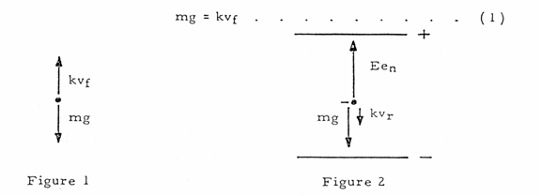

Figure 2 shows the forces acting on the drop when it is rising under the influence of an electric field. In Figure 2, E is the electric intensity, e_{n} is the charge carried by the drop, and is the velocity of rise. Adding the forces vectorially yields:

Ee_{n} = mg + kv_{r} . . . . . . . . . ( 2 )

In both cases there is also a small buoyant force exerted by the air on the droplet. Since the density of air, however, is only about one-thousandth that of oil, this force may be neglected.

Eliminating k from equations ( 1 ) and ( 2 ) and solving for the e_{n} yields:

. . . . . . . . . ( 3 )
To eliminate m from equation ( 3 ), one uses the expression for the volume of a sphere:
m = (4/3) . . . . . . . . . ( 4 )

Where a is the radius of the droplet, and is the density of the oil.

- 2 -

To calculate a, one employs Stokes’ Law, relating the radius of a spherical body to its velocity of fall in a viscous medium (with the coefficient of viscosity, ).

a = . . . . . . . . . ( 5 )

Substituting equations ( 4 ) and ( 5 ) into equation ( 3 ) yields:

e_{n} = x . . ( 6 )

Stokes’ Law, however, becomes incorrect when the velocity of fall of the droplets is less that 0. 1 to 0. 001 cm./sec. (Droplets having this and smaller velocities have radii, on the order of 2 microns, comparable to the mean free path of air molecules, a condition which violates on of the assumptions made in deriving Stoke’s Law.) Since the velocities of the droplets used in this experiment will be in the range of 0. 01 to 0. 001 cm./sec., a correction factor must be included in the expression for e_{n.} This factor is:

. . . . . . . . ( 7 )

Where b is a constant, p is the atmospheric pressure, and a is the radius of the drop as calculated by the uncorrected form of Stokes’, equation ( 5 ).

The electric intensity is given by E = V/d, where V is the potential difference across the parallel plates separated by a distance d. E, V, and d are all expressed in the same system of units. If E is in electrostatic units, V in volts, and d in centimeters, the relationship is:
E (e. s. u.) = . . . . . . ( 8 )
Substituting equations ( 7 ) and ( 8 ) into equation ( 6 ) and rearranging the terms yields:
e_{n} = x x e.s.u. . ( 9 )
The terms in the first set of brackets need only be determined once for any particular apparatus. The second term is determined for each droplet, while the term in the third set of brackets is calculated for each change of charge which the drop experiences.

_____________
* For additional information about Stokes’ Law the student is referred to Introduction to Theoretical Physics, by L. Page (New York, Van Nostrand).
Chapter 6.
** A derivation of this may be found in The Electron by R.A. Millikan (Chicago, The university of Chicago Press), Chapter 5.

- 3 –

The definitions of the symbols used, together with their proper units for use in equation
( 9 ) are:

e_{n} - The charge, in e.s.u., carried by the droplet.
d - Separation of the plates in the condenser in cm.
- Density of the oil in gm/cm.³
g - Acceleration of gravity in cm./sec.²
- Viscosity of air in Poise (dyne sec./cm.²)
b - Constant, equal to 6. 17x10⁻⁴.
p - The barometric pressure in cm. Of mercury.
a - The radius of the drop in cm. As calculated by equation ( 5 )
v_{f} - The velocity of fall in cm./sec.
v_{f} - The velocity of rise in cm./sec.
V - The potential difference across the plates in volts.

The accepted value for e is 4. 803x10⁻¹⁰ e.s.u.

- 4 –

ADJUSTMENT AND CALIBRATION OF APPARATUS
1. SETTING UP: The apparatus should be place on a level, solid table, with the viewing scope at a height which permits the experimenter to sit erect while observing the drops. The power cord is connected to a 110/130 VAC, 50/60 cycle receptacle and the Plate Control box (which houses the three position lever switch) is connected to the main chassis by means of the cable connector.

CONDENSER ASSEMBLY

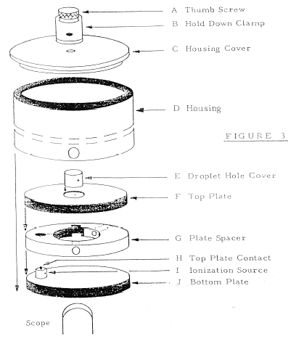
CORNELL UNIV.
PHYSICS DEPT.
410 – 510
LABORATORY

2. LEVELING: The Thumb Screw (A) is loosened and the Plexiglass Hold Down Clamp (B) is turned 90º . The condenser assembly is now disassembled by removing parts: (Figure 3) C, Housing Cover; D, Housing; E, Droplet Hole, Cover; F, Top Plate; and G. Plate Spacer.

- 5 –

The unit is leveled by placing a small level on the bottom brass plate and adjusting the three leveling screws on the bottom of the main chassis. NOTE: Reasonable care must be exercised when handling the brass plates to insure that no scratches or pits are formed on the blued sides of either plate. The same care should also be exercised with the plate spacer. Any irregularity on the plane surfaces of these parts will make measurement of the plate separation extremely difficult.

3. VOLTMETER CONNECTION: A voltmeter, range 0 – 400 VDC, (or higher) is connected to the binding posts on the side of the chassis. The internal resistance of this meter should not be less than 1 megohm. An internal resistance less than this value will make the voltage regulation circuit inoperative at lower line voltages.

As will be noted in equation 9 on page 3 the plate potential is an inversely proportional factor in calculating the charge on a droplet. Therefore, the meter used should have as high an accuracy as possible, and should have a large enough scale so that the plate potential can be read to the stated accuracy of the meter.

The high voltage supply is turned on by the POWER switch on the main chassis. The plate potential is varied by the PLATE POTENTIAL control on the main chassis.

A warm up period of about 5 minutes is required for stabilization of the high voltage supply. This period provides time to accustom the eye to viewing the drops and to develop the technique for introducing the drops into the condenser (Steps 10 and 11).

4. MEASURING PLATE SEPARATION: The distance between the condenser plates is determined by measuring the thickness of the plate spacer used to separate the plates. Two possible methods are suggested for making the measurement:
a) The thickness of the plate spacer (Part G) is measured with a micrometer around the outer rim and the average value used.
b) A more accurate method is to place the plate spacer between two small (2.5˝ x 2.5˝) pieces of plate glass and measure the combined thickness of the three. The point of measurement should be as close to the center of the plate spacer as possible. The spacer is then removed and the thickness of the two glass plates measured. Subtracting the latter quantity from the former quantity gives the separation of the plates. This method has the advantage of taking into account any surface imperfections which may have been formed on the surface of the spacer. NOTE: All surfaces involved in the measurement should be clean to prevent inaccurate readings.

5. MEASURING RETICULE LINE SEPARTATION: The distance between the top of the upper reticule line and the top of the lower reticule line may be measured in the following way. A microscope reticule, ruled in 0.01 mm. is placed on the bottom brass plate and the scope focused on the reticule.

This distance should be measured to the limit of the experimenter’s ability since an accuracy of ⁺ 0.01 mm., when the reticule line separation is 0.5 mm., produces an error factor of ⁺ 2%. NOTE: A label, to the right of the scope, gives the factory calibration of the reticule separation.

- 6 –

6. CLEANING AND REASSEMBLY: The condenser housing, plates, spacer, and droplet hole cover should be cleaned, with particular attention to the droplet hole, the glass observation port covers on the condenser housing, and the droplet hole cover. Water and detergent make a suitable cleaning fluid. Solvents which might attack the plastic plate spacer should be avoided. All parts should be completely dry before reassembly. The condenser assembly is reassembled except for the housing cover (Part C) and the droplet hole cover (Part E). The two glass ports on the housing (Part D) should line up with the ports of the plate spacer. The spring contact (Part H) should make good electrical contact with the top plate (Part F). All parts are oriented as shown in Figure 3.

7. ADJUSTING THE OPTICAL SYSTEM: A short piece of wire, or a pin (less than 0.010" dia.) is inserted through the hole in the center of the top plate and made to extend enough so as to touch the bottom plate when the condenser is assembled. The POWER switch is turned ON. The focusing lever, on the right side of the chassis to which the scope is mounted, is moved either forward or backward until the wire is in sharp focus. If the wire cannot be seen at all, check the orientation of the plastic spacer and the condenser housing (Figure 3 and step 6). If the wire is still not visible, adjust the light source, in the manner described in the next step, until the wire is visible and focus the scope.

NOTE: The screws marked “A” in figure 4 control the sliding friction of the scope. When properly adjusted, the scope should slide smoothly, with a small amount of friction to prevent the scope from being knocked out of focus when the instrument is used. Tightening the screws will increase the friction in the system, and vice versa. Just a slight adjustment of the screws will produce very noticeable changes in the sliding friction of the scope.

While viewing the wire, adjust the eyepiece, by turning it, until the reticule lines and wire are both in sharp focus.

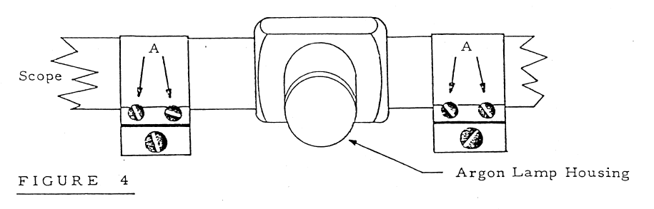

8. ADJUSTING THE LIGHT SOURCE: Remove the light source housing (to the right and rear of the Condenser Assembly) by lifting the housing off its base. The #55 lamp in the light source can be moved both in the horizontal and vertical planes. While viewing the focusing wire through the scope adjust the lamp assembly until the wire is at it’s maximum illumination at the area on the wire between the two reticule lines. Replace the light sources housing. Figure 5 (on the following page) presents the details of the light source.

- 7 -

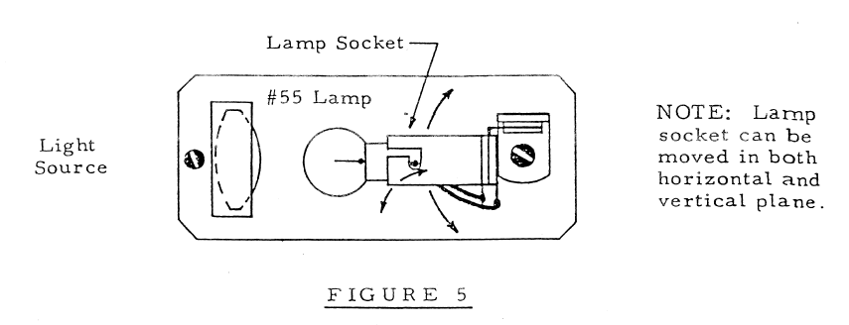

9. Remove the focusing wire or pin from the top plate and place the condenser housing cover and droplet hole cover in position, as shown in Figure 3. The Hold Down Clamp (Part B) is rotated so that it is over the condenser housing and the Thumb Screw is tightened. The apparatus is now ready for making measurements.

FUNCTIONS OF CONTROLS:

RADIATION SOURCE lever – When the lever is at the OUT position the radiation source is shielded on all sides by plastic, so that virtually no radiation enters the area of the drops. At the IN position the plastic shielding is removed and the drop area is exposed to the radiation source. NOTE: Move the radiation source lever gently to avoid jarring the condenser assembly and knocking the droplet from the viewing area.

The radiation source, initial strength, and the date of initial strength are all specified on the radiation tag to the left of the radiation source lever.

PLATE CHARGING CONTROL SWITCH – When the three way lever plate control switch is in the OFF position the condenser plates are disconnected from the high voltage supply and grounded. When the switch is in the TOP PLATE + position the top plate is positive with respect to the bottom plate. When the switch is in the TOP PLATE – position the top plate is negative with respect to the bottom plate.

PROCEDURE FOR DETERMINING THE CHARGE ON A DROP

10. ROOM ILLUMINATION AND CONTROL SETTINGS: The room should be made as dark as possible. There must be enough light, however, for reading the voltmeter, stopwatch, and recording data. The POWER switch is turned ON, the Plate Control switch is in the OFF position, and the RADIATION SOURCE lever is at the IN position. The RETICULE ILLUMINATION control should be set so that the reticule lines are just bright enough to be easily visible. Excessive illumination of these lines may make it difficult to observe very small droplets. Non-volatile oil, with a know density, is place in the atomizer (Squibb #5597 Mineral Oil (density – 0.886 g/cc) is very satisfactory).

- 8 -

11. INTRODUCING DROPS INTO THE CONDENSER: The nozzle of the atomizer is placed into the hole of the condenser housing cover. A few quick “squirts” of oil will fill the upper chamber of the condenser with drops and begin to force some drops into the viewing area. If no drops are seen, squeeze the atomizer bulb gently until drops appear in the viewing area. If repeated “squirts” of the atomizer fail to produce any drops in the viewing area, but rather a cloudy brightening of the field, the hole in the top plate is probably clogged, and should be cleaned.

The exact technique of introducing drops will have to be developed by the experimenter. The object is to get a small number of drops, not a large, bright cloud, from which a single drop can be chosen. It is important to remember that the drops are being forced into the viewing area by the pressure of the atomizer. Therefore, excessive use of the atomizer can cause too many drops to be forced into the viewing area and, more important, into the area between the condenser wall and the focal point of the scope. Drops in this area prevent observation of drops at the focal point of the scope.

NOTE: If the entire viewing area becomes filled with drops, so that no one drop can be selected, either wait three or four minutes until the drops settle out of view, or disassemble the condenser, thus removing the drops. When the amount of oil on the condenser parts becomes excessive, clean the assembly as explained in Step 6. The less oil that is sprayed into the chamber, the fewer times the chamber must be cleaned.

12. SELECTION OF DROP: From the drops in view the experimenter should select a droplet which both falls slowly, and when the plates are charged, rises slowly. The following example is given as a guide in selecting a drop.

A drop which requires about 15 seconds to fall the distance between the reticule lines (about 0. 05 cm.) will rise the same distance, under the influence of an electric field (about
1000 v. /cm.), in the following times with the following charges 15 sec. – 1 excess electron; 5 sec. – 2 excess electrons; 3 sec. – 3 excess electrons. (NOTE: Theses values are only approximate).

IMMEDIATELY after the drop is selected move the RADIATION SOURCE lever to the OUT position.

About 20 measurements of the rise and fall velocities of the drop should be made and the charge of the drop calculated. If the result of this first determination for the charge on the drop is greater than 5 excess electrons, then the experimenter should use slower moving drops in subsequent determinations.

13. CHANGING THE CHARGE: Drops are again introduced into the viewing area and a new drop is selected. After about 20 measurements on this drop have been made, the drop is brought to the top of the field of view and allowed to fall with the RADIATION SOURCE lever at the IN position. A few seconds later the plates should be charged, and, if the rising velocity has changed, then the RADIATION SOURCE is moved to the OUT position and a new series of measurements taken. If, however, the charge has not changed. Then turn the Plate Control Switch to OFF and allow the drop to continue falling. After a few seconds, again check for a change in the rising velocity. Continue this procedure until the drop has captured an ion.

- 9 –

If the drop captures an ion such that the drop moves rapidly downward, then reverse the polarity of the plates so that the drop can be made to rise.

Make about 20 measurements of the rising and falling velocity of the drop, and if possible, change the charge again and repeat the measurement procedure.

13. It is desirable to observe as many changes of charge on a single drop as possible.

14. The plate potential is recorded for each determination; the density of the oil determined; the viscosity of the air (at room temperature) found from a suitable hand book; and the barometric pressure recorded.

The experimenter is now ready to compute the charge of an electron and, through analysis of the data collected, demonstrate the granular nature of electricity.

IMPORTANT

During the observation of a drop the experimenter must not jar the apparatus, or the droplet may be knocked out of the viewing area. This is the reason for the separate control box.

HIGH VOLTAGE SUPPLY SPECIFICATIONS

Power Input: 110/130 VAC, 50/60 cps.
Range: 300-400 VDC, continuously variable.
Regulation: 1% for 10% line variation.
Ripple: less than 0. 1 volt.
Stability: within 1% after warm up.

A schematic of the high voltage supply, with the specifications of all components, is given on page 19.

- 10 -

