ERL@Cornell
Review before manufacture of 1st Cryomodule
3 October 2012

Report date: 10 October 2012
Reviewers: Serge Claudet (CERN), Tom Peterson (Fermilab), John Weisend (ESS)

Charge:
- Review the ERL Main Linac Cryomodule (MLC) and evaluate whether the design suitable for the ERL parameters. Consider the cryogenic, mechanical, potential for cost reduction and simplifications.
- Review the prototype MLC that will be tested individually, and evaluate whether its design and its planned tests will yield sufficient insight of the ERLs MLC.
- Write a short report of your findings, if possible before October 14, 2012.

Summary:
The MLC design is well developed, and a significant amount of analysis and thought have gone into it. The ERL team has made good use of their experience with the injector cryomodule (CM) along with experience from other Cornell projects and projects from other labs. We were impressed by the work which has been done both in designing a large ERL system and in planning for this prototype cryomodule. In general, the MLC design is conservative & should meet the machine requirements. We think the prototype cryomodule will provide very valuable experience in design, fabrication, and assembly as well as interesting data for the future ERL. Excellent work!

Organization of the presentations was well structured and adequate for discussions. No major issues were observed. Our report is organized into “comments” and “recommendations”, the latter a stronger suggestion of some action.

Comments:
- HOM cooling with 40 – 80 K flow may result in unbalanced flows with unequal heat loads. We suggest planning tests of unbalanced loads on thermal intercept circuits in the prototype CM. One could also consider adding some flow resistance on the 40 K side of the capillary cooling tube to the HOM absorbers.
- In a large ERL system, one could add a bypass valve (from 4.5 K supply to 6 K return) at turnaround at far end for 4.5 to 6 K flow control.

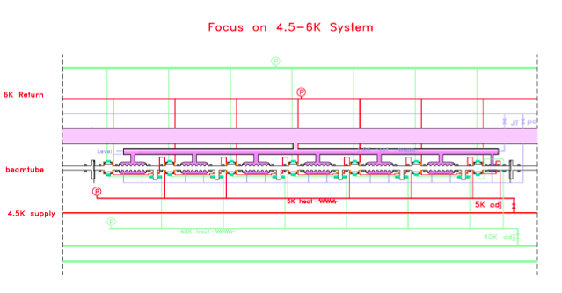

- In a large ERL system, consider adding a bypass valve at cryoplant end from 40 K manifold to 80 K return.

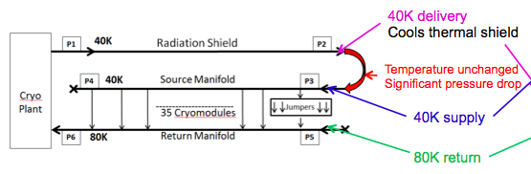

- Instrumentation: We suggest no active pumping while cold. May not need temperature sensors on 2-ph line except for cool-down and warm-up. Measure helium gas return pipe pressure at feed box.
- Safety. No new or unusual issues relative to other large cryogenic installations. Pressure vessel requirements may be more relaxed than for a DOE lab but still require some attention (generally meet intent of the codes).
- It is an interesting analytical result that pump-down may provide a slight asymmetric deformation of the vacuum vessel resulting in lateral motion of the cavity 0.3 mm away from input coupler. (This could be checked with WPM in prototype cryomodule, as well as cool-down motion.)
- For the large ERL string cool-down, a bypass line from the 5 K line to the 300 mm pipe could provide some extra cool-down flow to the pipe to alleviate the different cool-down rates of the cavities and 300 mm pipe (pipe having more mass and heat capacity).
- Piping will be a bit different in the prototype cryomodule relative to a production ERL cryomodule, but no big axial loads. (Bellows at reduced pipe ends are different.) 80 K to 120 K cooling of HOM absorbers, not 40 K to 80 K. Valves will be in the production cryomodule positions and environment. Cryogenic valves cannot withstand displacements at cold interfaces, additional flexibility in piping to minimize forces on the valves should be considered.
- The ERL cryomodule interconnect bellows should have internal sleeves.
- Pipes in the ERL cryomodule interconnect will have to be checked for mechanical stability (for example, against lateral offset) with up to 20 bar pressure. The sheet metal thermal shield may not be sufficiently rigid support.
- There will be longitudinal forces at linac termination boxes. Axial loads should be taken by end boxes in the ERL system.
- Prototype cryomodle provides a different situation not requiring reaction of large loads. But attention still needs to be given to thermal contraction and pipe support and stability. (We did not see all the details.)
- If 1.6K is to be considered as a fall-back solution, specific checks of corresponding circuit need to be made (valves, LHe pipe, GHe pipe) for 1.6 K operation.
- With a factor 2 margin with respect to predicted 2K heat loads (allowing for possibly low Q of cavities in one cryomodule), an operating scenario for static losses of only 5% of installed capacity may occur during early days of operation. A static heat load of 5% of full design heat load means valve control will probably be a problem due to very low flow. Smaller valve plugs at the valve stem extremity could help in this situation. Exchangeable plugs and seats in 2 K supply valves, which are typical features in cryogenic valves, could prove to be valuable when extended periods of operation in a low flow mode are anticipated.
- Operation at reduced capacity: the thermal shield would significantly warm-up if corresponding flow would be reduced by a factor 10, inducing long thermal oscillation when resuming nominal operation. This effect could be largely minimized by one additional valve at linac extremity to guarantee minimal flow in thermal shield manifold.
- If cooling down faster would be an advantage, a by-pass valve at extremity of the linac between 5K and 2K supply lines (both low pressure rating) would help cooling the Helium Gas Return Pipe.
- Significant detailed work remains but the ERL team appears well equipped to carry out this work. No obvious cost savings have been identified. The large number of parallel cooling paths for HOM absorbers, couplers and heat intercepts result in a complicated though tractable design.
- The prototype design should test almost all of the design issues associated with the MLC and will prove very valuable for the future ERL linac. But there are two significant areas that won’t be tested in this prototype:
  - The cryomodule to cryomodule interconnection. Parts of this could be tested via room temperature mockups and the overall risk associated with this item is low as it is based on existing designs such as the ILC
  - The handling of the piping loads at the end of the final linac. This issue poses a moderate risk and must be addressed by further detailed design efforts.

Recommendations:
- Given the preponderance of dynamic heat loads and the potential uncertainty in them, ERL designers should reevaluate the overall 1.5 safety factor for the cryogenic load. Consider using different safety factors (some higher and some lower) for different temperature levels and different heat loads (i.e. the cavity or HOM safety factor may be higher while the thermal shield safety factor may be lower). As the project develops and more information is received on some of these issues (for example, better cavity performance data or better information on the HOM loads) then the safety factors associated with these items may be adjusted.
- The ERL team should make every use of intermediate tests and prototypes to reduce the uncertainty in the various dynamic heat load terms. Resources spent in this effort will be justified in the long term.
- Cold electrical feed throughs should be avoided. Room temperature feed throughs should be used whenever possible.
- Constant pumping of the cryomodule isolation vacuum is not required. An initial pump down followed by cryopumping should be sufficient. Provisions should be made to attach portable vacuum pumps to the cryomodule while it is still cold if leaks develop in the system after operation begins.
- Having two room temperature pressure transducers on the helium gas return pipe (one on each end of the linac) should be sufficient.
- Consider the addition of a small reservoir on the two phase tube at the end of each cryomodule to allow more accurate level measurement.
- Specifically for the ERL cryomodule prototype:
  - Mechanical: Extremities to be looked at in more details for thermal contraction compensation, pressure effect on supply interface and relative movements between pipes
  - Thermal: Operation of HOM at higher temperature will induce extra load on the 5K intercept that should be explicitly evaluated to avoid detrimental effects on the Niobium 1.8K part (superconducting transition?)
- The proposed baffle for low pressure gas looks like an elegant alternative to a second connection between the 2-phase pipe and helium gas return pipe (HGRP). It would effectively cool the HGRP extremity while keeping the 2-phase pipe standard.

Website: http://www.lepp.cornell.edu/Events/MLCExternalReview/

Agenda:
http://www.lepp.cornell.edu/Events/MLCExternalReview/Agenda.html

October 3, 2012, 8:30-5:00pm, 311 Newman

8:30: Welcome, closed session
9:00: Purpose of the internal, external review and project objectives (Georg,5 min discussion)
9:20: Cryomodule overview pdf, ppt (Yun, 5 min)
9:35: SRF results and requirements: cavities, coupler, tuner & HOM loads pdf, pptx (Matthias, 10 min)
10:00: Cryogenic principle of the module pdf, pptx (Eric, 5min)
10:20: Coffee break
10:40: Mechanical design, choice of material, production steps pdf, ppt (Yun, 10 min)
11:20: Cryogenic Piping pdf, pptx (Eric, 5 min)
11:35: Inter-module Connections pdf, pptx (Dan, 5 min)
11:50: Instrumentation pdf, ppt (Peter, 5 min)
12:00: Safety requirements and regulations pdf, ppt (James, 10 min)
12:20: Lunch
12:50: Stress and cool-down analysis pdf, ppt (Yun, 5 min)
1:10: Alignment and assembly pdf, ppt (Yun, 5 min)
1:30: Cryogenic cool down scheme pdf, pptx (Eric, 5 min)
1:50: MLC prototype modifications, mechanics pdf, ppt (Yun, 5 min)
2:05: MLC prototype modifications, cryogenics pdf, pptx (Eric, 5 min)
2:20: Discussions
3:15: Gimmi! Coffee
3:30: write-up
4:30 - 5:00: Close-out

